A Hybrid Blockchain Framework for Privacy-Preserving Contact Tracing in Smart Tourism: Integrating Role-Based Access Control and Off-Chain Storage

Abstract

Blockchain-based contact tracing promises transparency but faces critical scalability and access control challenges. Existing solutions store data entirely on-chain, creating prohibitive costs, or lack role differentiation, risking privacy violations. This paper proposes the Privacy-preserving Contact Tracing Framework (PCTF), a hybrid architecture combining off-chain encrypted storage with protocol-level role-based access control. PCTF maintains 97% of sensitive data off-chain while enforcing fine-grained permissions across tourists, hotels, hospitals, and public health authorities. A prototype implementation on Ethereum demonstrates stable performance under increasing workload, with 100% success rate for 200+ concurrent record creations and average gas consumption of 288,878 units per operation. All unauthorized access attempts are rejected at the smart contract level, confirming effective protocol-level enforcement. Comparative analysis shows PCTF achieves 88% reduction in storage costs versus fully on-chain approaches while providing structured access control absent in existing hybrid models. The proposed framework offers a scalable, privacy-compliant foundation for multi-stakeholder contact tracing in smart tourism ecosystems

1. Introduction
The rapid digitalisation of global industries has introduced significant challenges in managing large-scale sensitive data across multi-stakeholder environments. The tourism sector, inherently cross-border and highly interconnected, faces critical issues related to data security, interoperability, and public health management. The COVID-19 pandemic exposed fundamental limitations in existing tourism infrastructures, particularly the absence of reliable and privacy-preserving contact tracing mechanisms capable of operating across institutional and jurisdictional boundaries. Centralised systems remain inadequate due to their susceptibility to single points of failure, lack of interoperability, and inability to enforce differentiated access control across diverse stakeholders.
Tourism is a major contributor to the global economy, accounting for approximately 10% of global GDP and supporting one in ten jobs prior to the pandemic (Pincheira et al., 2020). Despite this scale, its operational infrastructure remains heavily centralised and fragmented, relying on intermediary-driven processes and siloed data management across accommodation providers, transport systems, and public health authorities. The pandemic further highlighted these structural inefficiencies, where the lack of trusted mechanisms for sharing health-related data significantly hindered coordinated response efforts (Klaine et al., 2020). Beyond public health crises, traditional tourism systems continue to face challenges related to transparency, fraud, identity management, and technological integration. These limitations are summarised in Table 1.Table 1 summarises eight critical areas in which centralised tourism systems demonstrate significant operational deficiencies.
Table 1: Areas of impact in the tourism industry
Area | Description | Reference
Transparency | Centralised booking and transaction systems offer limited visibility to end users, creating information asymmetries between providers and consumers | (Vernekar, 2020)
Settlement | Financial clearing between tourism stakeholders — including hotels, airlines, and agents — relies on slow intermediary processes that increase costs and delays | (Kumar, 2025)
Loyalty | Fake reviews and manipulated reward programmes undermine consumer trust in tourism platforms | (Pincheira et al., 2020)
Fraud | Single points of failure in centralised architectures create systemic vulnerabilities to data breaches and payment fraud | (Kumar, 2025)
Identity | Centralised storage of personal traveller data creates high-value targets for identity theft and unauthorised data access | (Vernekar, 2020)
IoT Integration | Existing tourism systems lack standardised protocols for integrating smart devices such as connected hotel rooms and transportation sensors | (Kumar, 2025)
Overbooking | Centralised reservation systems with poor real-time synchronisation create booking conflicts and service failures | (Kumar, 2025)
Contact Tracing | Traditional tourism infrastructure has no reliable, privacy-preserving mechanism to identify and notify individuals exposed to infectious disease | (Klaine et al., 2020)

Figure 1 illustrates the siloed architecture of conventional tourism systems, where disconnected stakeholders operate without a unified data layer or interoperable communication framework. This fragmentation prevents the reconstruction of traveller interaction histories and delays exposure notification during public health emergencies, highlighting the need for a decentralised and interoperable solution.
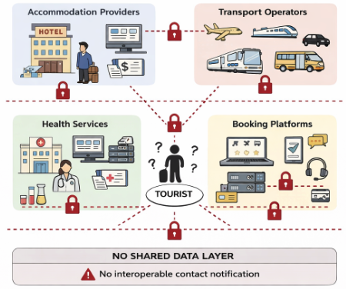
Figure 1: Traditional tourism architecture — disconnected silos across accommodation providers, transport operators, health services, and booking platforms, with no shared data layer or interoperable contact notification mechanism.
Blockchain provides a decentralised and tamper-resistant infrastructure for secure data sharing across untrusted entities. By eliminating reliance on a central authority, blockchain enables transparent, verifiable, and immutable record management through distributed consensus mechanisms (Agbo et al., 2019; Hasselgren et al., 2020). Smart contracts further extend this capability by enabling automated execution of predefined rules, including access control enforcement, exposure notification, and data provenance tracking (Hasan et al., 2021). These characteristics make blockchain particularly suitable for multi-stakeholder environments such as smart tourism systems. The key features and advantages of blockchain in this context are summarised in Table 2.Table 2 summarises eight core features of blockchain technology and their relevance to the smart tourism contact tracing context.
Table 2: Key features and advantages of blockchain technology
Feature | Explanation
Secure Transactions | Cryptographic hashing and digital signatures prevent unauthorised data modification and protect the integrity of all recorded contact events
No Intermediaries | Peer-to-peer architecture enables direct, verifiable data exchange between tourists, hotels, hospitals, and authorities without requiring a trusted third-party broker
Data Integrity | Once validated and written to the chain, contact and health records cannot be altered or deleted, providing a permanent and forensically reliable audit trail
Decentralisation | The absence of a central server eliminates the single point of failure that renders conventional tourism data systems vulnerable to outages and targeted attacks
Immutability | The cryptographic linkage between blocks ensures that historical records remain unchanged, supporting accountability in public health investigations
Transparency | All authorised participants share access to the same ledger state, reducing information asymmetry and enabling coordinated, evidence-based public health responses
Trust Enhancement | Cryptographic proof of data origin and integrity substitutes for institutional trust, enabling cross-border cooperation between stakeholders with no prior relationship
Privacy-Preserving Contact Tracing | Pseudonymous identifiers and selective data disclosure mechanisms allow exposure notifications to be issued without revealing unnecessary personal details to unauthorised parties
Sources: Agbo et al. (2019); Hasselgren et al. (2020); Hasan et al. (2021); Sookhak et al. (2021)
Beyond its foundational properties, blockchain has demonstrated practical applicability in tourism-related scenarios, including payment settlement, health credential verification, and cross-border data exchange (Nam et al., 2021). However, existing blockchain-based contact tracing frameworks remain limited in two critical aspects. First, most approaches rely on on-chain storage of contact records, leading to scalability constraints and increased transaction costs. Second, they apply uniform access control policies, failing to account for the heterogeneous roles of stakeholders such as tourists, accommodation providers, healthcare institutions, and public health authorities. This lack of role differentiation introduces both privacy risks and operational inefficiencies.
Recent studies have shown that hybrid blockchain architectures—combining on-chain governance with off-chain encrypted storage—significantly improve scalability while preserving data integrity (Jayabalan and Jeyanthi, 2022; Miyachi and Mackey, 2021; Wang et al., 2021). However, these approaches do not adequately address the need for fine-grained, role-based access control in multi-stakeholder environments.
To address these limitations, this paper proposes the Privacy-preserving Contact Tracing Framework (PCTF), a novel blockchain-based architecture that integrates protocol-level role-based access control with a hybrid off-chain storage model. The proposed framework ensures that data access is restricted according to stakeholder roles while maintaining scalability through encrypted off-chain storage and cryptographic on-chain verification.
The primary contributions of this paper are as follows:
- A protocol-level role-based access control (RBAC) model enabling fine-grained access across multiple stakeholder categories
- A hybrid on-chain/off-chain storage architecture that significantly reduces blockchain storage overhead
- A privacy-preserving data management mechanism combining encryption, hashing, and pseudonymous identifiers
- A comprehensive simulation-based evaluation demonstrating scalability, efficiency, and security improvements over existing approaches
The remainder of this paper is structured as follows. Section 2 reviews existing literature on blockchain-based contact tracing and data management systems. Section 3 presents the system model and architectural design of the proposed framework. Section 4 describes the implementation methodology and validation approach. Section 5 provides experimental results and performance evaluation. Section 6 discusses key findings, limitations, and security implications. Finally, Section 7 concludes the paper and outlines future research directions.

2. Related Work
This section reviews existing contact tracing systems, blockchain-based solutions, hybrid storage architectures, and privacy-preserving frameworks. The analysis highlights critical limitations in scalability, access control, and multi-stakeholder governance, which collectively motivate the design of the proposed PCTF framework.

2.1 Non-Blockchain Contact Tracing Systems
Digital contact tracing systems were rapidly deployed during the COVID-19 pandemic, with early implementations primarily adopting centralized architectures. Singapore’s TraceTogether [1] represents one of the first national deployments, utilizing Bluetooth proximity data stored on centralized servers. While such systems enable efficient epidemiological analysis, they introduce significant privacy concerns due to centralized data aggregation and the presence of single points of failure [2].
To address these limitations, decentralized protocols such as the Decentralized Privacy-Preserving Proximity Tracing (DP-3T) framework [3] were introduced. DP-3T employs ephemeral identifiers and local storage of contact logs, ensuring that proximity data remains on user devices and preventing centralized reconstruction of contact graphs. Similarly, the Apple/Google Exposure Notification (GAEN) framework [4] operationalized decentralized contact tracing at global scale by leveraging rotating cryptographic identifiers and on-device exposure matching.
Despite their strong privacy guarantees and widespread adoption, these systems exhibit important limitations. They are primarily designed for proximity-based exposure notification and do not support structured data sharing across heterogeneous stakeholders such as tourism providers, healthcare institutions, and public authorities. Moreover, they lack fine-grained access control mechanisms and provide limited support for auditability and cross-institutional coordination. Hoepman [5] further critiques GAEN for introducing latent surveillance risks and dependency on platform providers.
Additional studies reinforce these concerns. Buckee et al. [6] demonstrate the feasibility of using aggregated mobility data for contact tracing without individual tracking, while Ahmed et al. [7] analyze 32 national applications and identify widespread privacy violations and excessive centralization. These findings indicate that although non-blockchain systems effectively address privacy-preserving exposure notification, they fail to provide comprehensive multi-stakeholder data governance.

2.2 Blockchain-Based Contact Tracing Systems
Blockchain technology has been widely explored as an alternative infrastructure for contact tracing, offering decentralization, immutability, and auditability. Hasan et al. [8] and Song et al. [9] proposed Ethereum-based frameworks that store contact and location data directly on-chain, ensuring tamper-resistant records. However, these approaches suffer from significant scalability limitations due to high transaction costs and storage overhead, making them impractical for large-scale deployment.
Furthermore, these systems lack role-based access control, treating all participants as homogeneous entities. This uniform access model increases the risk of unnecessary data exposure and does not reflect real-world operational requirements where access privileges differ across stakeholders.
Several enhanced approaches have been proposed to address privacy concerns. Xu et al. [10] introduced BeepTrace, a blockchain-enabled system that desensitizes identity and location data while enabling interaction with authorized entities. Tahir et al. [11] proposed a solution based on homomorphic encryption, allowing computation over encrypted data; however, this introduces substantial computational overhead. Lv et al. [12] and Garg et al. [13] developed decentralized and IoT-integrated blockchain solutions that improve privacy through pseudonymity but do not incorporate structured access control mechanisms.
More recent work by Li et al. [14] integrates zero-knowledge proofs and aggregate signatures to enhance efficiency and privacy. While these approaches improve cryptographic robustness, they still fail to provide role-based access differentiation across stakeholders.
Bandara et al. [3] explored Self-Sovereign Identity (SSI) for decentralized identity management, improving user control over credentials. However, the framework does not address role-specific access requirements or tourism-specific operational contexts. Similarly, Idrees et al. [4] highlight that existing blockchain-based systems prioritize decentralization and privacy but largely overlook the need for fine-grained access governance.

2.3 Hybrid On-Chain/Off-Chain Storage Architectures
Scalability remains a fundamental limitation of blockchain-based systems, particularly in high-frequency environments such as contact tracing. Storing large volumes of data directly on-chain leads to increased latency, high costs, and performance degradation.
To address these challenges, hybrid storage architectures have been proposed. Miyachi and Mackey [15] introduced a privacy-preserving healthcare framework that combines on-chain verification with off-chain encrypted storage, significantly reducing blockchain overhead while maintaining data integrity. Jayabalan and Jeyanthi [16] further demonstrate that fully on-chain storage is unsuitable for large-scale applications due to prohibitive computational and economic costs.
Kumar et al. [17] implemented a consortium blockchain integrated with IPFS for storing diagnostic data, where only cryptographic hashes are stored on-chain. Their results show improved performance and reduced block mining time. Additionally, surveys by Nguyen et al. [18] and Ojokoh et al. [19] emphasize the need for integrated architectures that simultaneously address scalability, privacy, and interoperability.
However, existing hybrid models primarily focus on storage efficiency and do not incorporate structured access control mechanisms. As a result, entities possessing off-chain references may access data without appropriate authorization, introducing potential privacy risks.

2.4 Role-Based Access Control in Blockchain and Healthcare Systems
Role-Based Access Control (RBAC) has been explored in blockchain-based healthcare systems as a mechanism for regulating data access across multiple stakeholders. Sookhak et al. [20] identify key limitations in existing approaches, including coarse-grained permission structures, lack of dynamic role management, and insufficient support for multi-institutional environments.
Liu et al. [21] proposed a privacy-preserving medical data sharing framework using consortium blockchain and dual storage mechanisms. While their approach enhances privacy, it does not differentiate access across distinct roles such as tourists, service providers, and authorities. Similarly, Guo et al. [22] introduced a hybrid blockchain-edge architecture using attribute-based encryption, achieving patient anonymity but lacking protocol-level RBAC enforcement.
In practice, most blockchain-based contact tracing systems rely on uniform access policies, which violate the principle of least privilege and increase the risk of unnecessary data exposure. This limitation is particularly critical in smart tourism environments, where multiple stakeholders require controlled and role-specific access to sensitive data.

2.5 Comparative Analysis of Existing Frameworks
Table 3 provides a comparative overview of existing contact tracing and tourism data management frameworks, highlighting their storage models, access control mechanisms, privacy approaches, and key limitations.
The analysis reveals two persistent and interrelated challenges. First, most systems rely on fully on-chain storage, resulting in scalability constraints, high operational costs, and limited suitability for real-world deployment. Although hybrid architectures improve storage efficiency, they fail to enforce structured access control mechanisms.
Second, there is a consistent absence of role-based access control tailored to multi-stakeholder environments. Existing frameworks either lack access control entirely or implement coarse-grained models that do not reflect real-world operational requirements. This leads to excessive data exposure and challenges in regulatory compliance.
Additionally, non-blockchain systems such as DP-3T and GAEN focus primarily on privacy-preserving exposure notification and do not support structured data sharing, auditability, or cross-entity coordination.

Table 3: Comparison of Contact Tracing Frameworks
Study / System | Architecture | Storage Model | Access Control | Privacy Mechanism | Key Limitation
TraceTogether [1] | Centralized | Central Server | None | Pseudonymity | Single point of failure, privacy risks
DP-3T [3] | Decentralized | Local Device | None | Ephemeral Bluetooth IDs | No role differentiation, limited governance
GAEN [4] | Decentralized | Local Device | None | Rotating identifiers, on-device matching | Platform dependency, no auditability
Buckee et al. [6] | Analytical Model | Aggregated Data | None | Data aggregation | No individual-level control
Hasan et al. [8] | Blockchain | On-chain | None | Pseudonymity | High cost, poor scalability
Song et al. [9] | Blockchain | On-chain | None | Bluetooth-based pseudonyms | No role-based access
Xu et al. (BeepTrace) [10] | Blockchain | On-chain | None | Identity desensitization | No RBAC, limited governance
Tahir et al. [11] | Blockchain | On-chain | None | Homomorphic encryption | High computational overhead
Lv et al. [12] | Blockchain | On-chain | None | Decentralized privacy model | No multi-stakeholder support
Garg et al. [13] | Blockchain + IoT | On-chain | None | Pseudonymity | No fine-grained access control
Li et al. [14] | Blockchain | On-chain | None | Zero-knowledge proofs | No role differentiation
Miyachi & Mackey [15] | Hybrid | On/Off-chain | Limited | Encryption + hash linkage | No structured RBAC
Jayabalan & Jeyanthi [16] | Hybrid | On/Off-chain | None | Encryption + IPFS | No access governance
Kumar et al. [17] | Consortium Blockchain | Hybrid | Coarse-grained | Hash linkage + IPFS | No multi-role model
Liu et al. [21] | Blockchain + Cloud | Hybrid | Limited | Anonymous identity protection | No stakeholder-specific access
Guo et al. [22] | Blockchain + Edge | Hybrid | Attribute-based | Attribute-based encryption | No protocol-level RBAC
PCTF (This Work) | Blockchain (Hybrid) | On/Off-chain | Protocol-level RBAC | Encryption + RBAC + data minimization | —

2.6 Research Gap and Contribution
The analysis of existing literature demonstrates that current solutions address individual aspects—such as decentralization, privacy preservation, or scalability—but fail to provide a unified framework that simultaneously ensures scalability, fine-grained access control, and multi-stakeholder governance.
To address these limitations, this paper proposes the Privacy-preserving Contact Tracing Framework (PCTF), a novel blockchain-based architecture that integrates hybrid off-chain storage with protocol-level role-based access control.Unlike existing approaches, PCTF stores sensitive data off-chain in encrypted form while maintaining only minimal cryptographic references on-chain, thereby significantly improving scalability and reducing operational costs. Furthermore, PCTF introduces a formally defined RBAC model that enforces fine-grained access policies across heterogeneous stakeholders, including tourists, accommodation providers, healthcare institutions, and public health authorities.By combining scalable storage with enforceable access governance, PCTF provides a comprehensive and practically deployable solution that addresses the critical gaps identified in existing research.

3. PCTF Architecture and System Design
The COVID-19 pandemic demonstrated that conventional contact tracing methods are fundamentally inadequate in high-mobility tourism environments where individuals move rapidly across multiple venues, interact with numerous service providers, and cross jurisdictional boundaries within short timeframes. Manual tracing processes are too slow to respond to the exposure timelines of rapidly transmitted diseases, while existing digital contact tracing applications rely on centralised databases that present single points of failure, carry significant data breach risks, and apply no differentiated access logic for the diverse institutional stakeholders involved in epidemic response (Lucena et al., 2021). The Privacy-preserving Contact Tracing Framework (PCTF) addresses these limitations through a blockchain-anchored architecture that combines Ethereum smart contracts with two purpose-designed innovations: a formally specified role-based access control model and a hybrid off-chain storage mechanism. Together, these features enable PCTF to deliver scalable, privacy-compliant, and institutionally appropriate contact tracing across the full stakeholder landscape of smart tourism, including tourists, accommodation providers, hospitals, and public health authorities.

3.1 System Model
The Privacy-preserving Contact Tracing Framework (PCTF) is modelled as a distributed multi-entity system designed to support secure, scalable, and privacy-preserving data exchange across heterogeneous stakeholders in a smart tourism environment. The system is formally defined as:
$$S=\{U,H,C,A,SC,IPFS\}$$
where:
- $U$represents the set of users (tourists)
- $H$represents accommodation providers (hotels)
- $C$represents healthcare institutions (hospitals)
- $A$represents public health authorities
- $SC$represents the set of smart contracts deployed on the Ethereum blockchain
- $IPFS$represents the off-chain distributed storage layer
Each entity interacts through a set of system transactions defined as:
$$T=\{t_{reg},t_{record},t_{diagnosis},t_{access}\}$$
where:
- $t_{reg}$: user registration and role assignment
- $t_{record}$: contact event recording
- $t_{diagnosis}$: diagnostic data submission
- $t_{access}$: access-controlled data retrieval
The system operates under a role-based access control model, where each entity is assigned a predefined role that determines its permitted operations. Let $R=\{Tourist,Hotel,Hospital,Authority\}$denote the set of roles. A mapping function:
$$f:pk→R$$
assigns each public key $pk$to a specific role within the system.Data flow within the PCTF framework follows a hybrid storage paradigm. Sensitive data $D_{s}$is encrypted and stored off-chain in the IPFS layer, while only cryptographic references $H(D_{s})$, along with minimal metadata, are recorded on-chain:
$$D_{on}=\{H(D_{s}),metadata\}$$
This separation ensures that the blockchain maintains integrity and auditability without storing sensitive information directly.The formal system model provides a structured representation of entity interactions, data flow, and access control mechanisms within PCTF, enabling analytical reasoning about scalability, security, and storage efficiency in subsequent sections.
The formal system model described above is visually represented in Figure 2, which illustrates the layered architecture of the PCTF framework and the interactions between its core entities. The diagram maps the system components defined in $S=\{U,H,C,A,SC,IPFS\}$into four distinct layers: the user layer, application layer, blockchain layer, and off-chain storage layer. It further highlights the flow of transactions $T=\{t_{reg},t_{record},t_{diagnosis},t_{access}\}$across these layers, demonstrating how data is generated, processed, and accessed within the system.

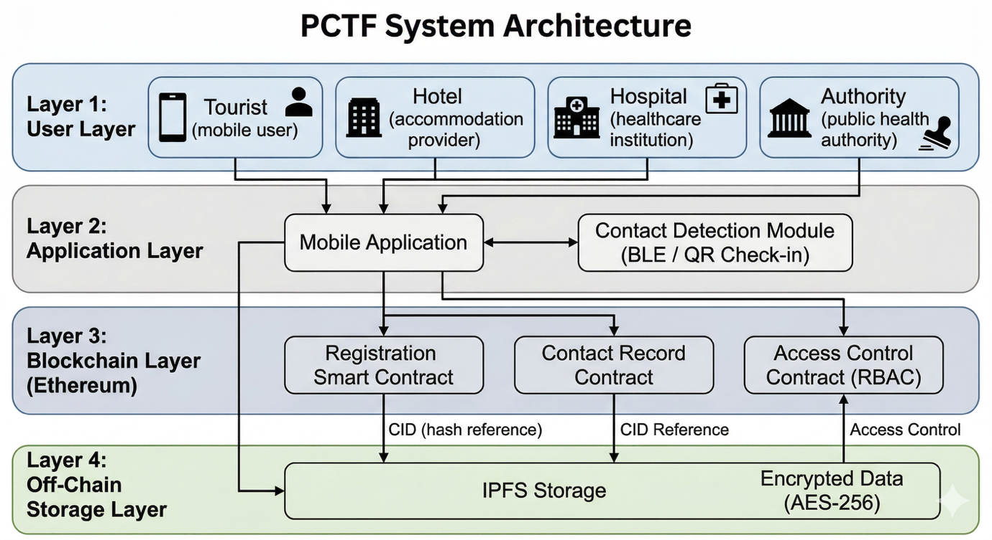
Figure 2: Layered architecture of the PCTF framework showing interactions between user entities, application layer, blockchain smart contracts, and off-chain IPFS storage with role-based access control
In particular, the figure shows that user entities interact with the application layer to initiate transactions, which are then validated and executed by the smart contract layer on the blockchain. Sensitive data $D_{s}$is encrypted and stored in the IPFS layer, while only cryptographic references $H(D_{s})$are recorded on-chain. The role-based access control function $f(pk)→R$governs all interactions, ensuring that access to data is restricted according to predefined permissions. This layered representation provides a clear mapping between the formal system model and its practical implementation within the PCTF architecture.

3.2 PCTF Architectural Components
The PCTF architecture is structured as a set of interdependent components that collectively enable secure, scalable, and privacy-preserving contact tracing in a multi-stakeholder tourism environment. Each component is designed to address a specific limitation identified in existing blockchain-based systems, including the absence of role-differentiated access control and the inefficiency of on-chain data storage.The architecture integrates blockchain-based smart contract execution with hybrid off-chain storage and protocol-level access control enforcement. The following subsections describe the key components of the PCTF framework.

A. User Registration and Role Assignment
User registration in PCTF establishes a pseudonymous identity and assigns a role that determines system-level permissions. Each participant generates an asymmetric cryptographic key pair, where the public key serves as the system identifier and the private key remains under user control.No personally identifiable information is recorded on-chain at any stage of the registration process. Instead, the public key is mapped to a predefined role through a registration smart contract, creating an immutable and verifiable association between identity and access privileges.Let $pk$denote the public key and $r∈R$represent the assigned role. The registration process can be expressed as:
$$f(pk)=r$$
This mapping ensures that role assignment is tamper-evident and verifiable without requiring a centralised identity authority. Role updates or revocations can be executed through authorised smart contract transactions, enabling dynamic adaptation to changing user affiliations.
This design adheres to the data minimisation principle embedded in the General Data Protection Regulation and is consistent with the pseudonymous identity approaches validated in blockchain health applications by Agbo et al. (2019).Following key generation, the registering entity is assigned one of four predefined role categories: Tourist, Accommodation Provider (Hotel), Healthcare Institution (Hospital), or Public Health Authority. Role assignment is performed through a dedicated registration smart contract deployed on the Ethereum network. The contract maps the user's public key to its designated role category and records this mapping as an immutable on-chain transaction. Role badges are therefore tamper-evident and verifiable by any system component without requiring a centralised identity registry. Roles may be updated or revoked by the system administrator through a subsequent smart contract call, providing flexibility for scenarios where a user's institutional affiliation changes during system operation (Sookhak et al., 2021).

B. Off-Chain Data Collection and Storage
The PCTF framework adopts a hybrid data storage model in which sensitive contact data is processed off-chain while only minimal cryptographic references are recorded on-chain. This design enables efficient storage management while preserving data confidentiality and integrity.Contact events are generated through two primary mechanisms: (i) venue-based interactions, captured via QR code or NFC check-ins at registered tourism locations, and (ii) proximity-based interactions, detected through Bluetooth Low Energy (BLE) communication between user devices. Each contact event produces a structured data object defined as:
$$D_{s}=\{pk_{i},pk_{j},t,d,v,status\}$$
where:
- $pk_{i},pk_{j}$: pseudonymous public keys of interacting users
- $t$: timestamp of interaction
- $d$: duration of contact
- $v$: venue identifier (if applicable)
- $status$: interaction state
To ensure confidentiality, the generated data $D_{s}$is encrypted prior to storage using the Advanced Encryption Standard (AES-256):
$$E=Enc_{AES}(D_{s},k)$$
where $k$is the symmetric encryption key controlled by the data owner.The encrypted payload $E$is then stored in the InterPlanetary File System (IPFS), which returns a unique content identifier (CID):
$$CID=H(E)$$
This CID serves as a deterministic cryptographic reference to the stored data. Instead of storing the full payload on-chain, the system records only the following metadata in the blockchain:
$$D_{on}=\{H(pk),CID,t,type\}$$
This approach ensures that the blockchain ledger contains no sensitive information, while maintaining verifiable linkage to off-chain data.The data flow process can therefore be summarised as:
- Capture contact event $D_{s}$
- Encrypt data → $E=Enc_{AES}(D_{s},k)$
- Upload encrypted data to IPFS → obtain $CID$
- Store $CID$and metadata on-chain
This hybrid architecture provides several advantages. First, it significantly reduces on-chain storage overhead by avoiding direct storage of large data payloads. Second, it enhances privacy by ensuring that only encrypted data exists off-chain and no plaintext information is exposed on the blockchain. Third, data integrity is preserved through cryptographic linkage, as any modification to the off-chain data would result in a mismatch with the stored CID.
Overall, this mechanism enables scalable and privacy-preserving data management within the PCTF framework while maintaining full auditability through blockchain-based verification.

C. Diagnostic Data Linking
The PCTF framework incorporates a diagnostic data linkage mechanism that connects confirmed infection events with previously recorded contact interactions while preserving data confidentiality. This component enables the system to identify potentially exposed individuals without revealing sensitive medical information on-chain.
When a user is diagnosed with an infectious disease, the healthcare institution (Hospital role) generates a diagnostic record associated with the patient’s pseudonymous identifier. Let the diagnostic record be defined as:
$$D_{d}=\{pk,t_{d},w\}$$
where:
- $pk$: public key of the diagnosed user
- $t_{d}$: timestamp of confirmed diagnosis
- $w$: infectious time window
To maintain privacy, the diagnostic data $D_{d}$is encrypted prior to storage:
$$E_{d}=Enc_{AES}(D_{d},k_{d})$$
where $k_{d}$is the encryption key controlled by the healthcare authority.The encrypted diagnostic record is then stored off-chain in the IPFS layer, producing a content identifier:
$$CID_{d}=H(E_{d})$$
Only the hash reference $CID_{d}$, along with minimal metadata, is recorded on-chain through the smart contract layer. This ensures that no medical information is exposed on the blockchain while maintaining a verifiable link to the diagnostic event.Following the recording of a diagnostic event, the system initiates an automated linkage process to identify relevant contact records. Let $C(pk)$denote the set of contact events associated with the diagnosed user. The system retrieves all contact records satisfying:
$$t∈[t_{d}-w, t_{d}]$$
where $t$represents the timestamp of each contact event. This temporal filtering ensures that only interactions within the infectious window are considered.
The resulting set of matched contact references is used by the smart contract layer to trigger exposure notification events for potentially affected users. Importantly, this process operates on pseudonymous identifiers and cryptographic references, ensuring that the identity of the diagnosed individual is not disclosed during notification.This diagnostic linkage mechanism provides three key properties. First, it enables automated exposure detection without requiring manual tracing processes. Second, it preserves medical data confidentiality by restricting sensitive information to encrypted off-chain storage. Third, it maintains auditability through blockchain-based hash verification, ensuring that all diagnostic events and associated contact linkages are tamper-evident.Overall, this component ensures that PCTF can support timely and privacy-preserving outbreak response in high-mobility environments such as smart tourism systems.

D. Smart Contract Execution
The PCTF framework utilises a set of specialised smart contracts deployed on the Ethereum blockchain to coordinate system operations, enforce access control, and maintain verifiable state transitions. These contracts act as the execution layer of the system, ensuring that all interactions are validated, recorded, and enforced at the protocol level.
The smart contract layer is defined as:
$$SC=\{SC_{reg},SC_{record},SC_{access}\}$$
where:
- $SC_{reg}$: manages user registration and role assignment
- $SC_{record}$: manages contact record indexing and diagnostic linkage
- $SC_{access}$: enforces role-based access control
Each contract operates as a deterministic state machine, processing transactions submitted by authorised entities and updating the blockchain state accordingly.

Registration Contract
The registration contract $SC_{reg}$establishes the mapping between user identities and roles. Given a public key $pk$, the contract stores:
$$M[pk]=r$$
where $r∈R$denotes the assigned role. This mapping is immutable unless explicitly updated through an authorised transaction, ensuring tamper-evident role assignment.

Record Management Contract
The record management contract $SC_{record}$maintains an index of contact event references stored on-chain. For each contact event, the contract records:
$$R_{i}=\{H(pk),CID,t,type\}$$
where $CID$corresponds to the off-chain encrypted data stored in IPFS.Upon submission of a diagnostic event, the contract executes a filtering operation to identify all relevant contact records associated with the diagnosed user within the infectious time window. Let $R(pk)$denote the set of all contact records associated with a user. The contract retrieves:
$$R^{'}(pk)=\{r_{i}∈R(pk)∣t_{i}∈[t_{d}-w,t_{d}]\}$$
where $t_{i}$is the timestamp of each contact event.This filtered set is used to trigger exposure notifications for affected users without revealing the identity of the diagnosed individual.

Access Control Contract
The access control contract $SC_{access}$enforces permission constraints for all data retrieval operations. For any request initiated by a user with public key $pk$, the contract evaluates:
$$Access(pk,d)=\left\{\begin{matrix}\text{allow}, & \text{if }f(pk)∈Perm(d) \\ \text{deny}, & \text{otherwise}\end{matrix}\right.$$
where:
- $f(pk)$returns the role of the requester
- $Perm(d)$defines the set of roles authorised to access data $d$
Unauthorised requests result in immediate transaction reversion, preventing execution of restricted operations and minimising gas consumption.

Automated Execution Flow
The smart contract execution process follows a deterministic workflow:
- A transaction is submitted to the blockchain
- The corresponding smart contract validates the caller’s role
- If authorised, the contract updates the on-chain state
- If unauthorised, the transaction is reverted
This execution model ensures that all system operations are verifiable, tamper-resistant, and enforced without reliance on centralised intermediaries.Overall, the smart contract layer provides a secure and decentralised execution environment that integrates identity management, contact record processing, and access control into a unified framework. By enforcing all critical operations at the protocol level, PCTF eliminates reliance on application-layer trust assumptions and ensures consistent system behaviour across all participating entities.The onlyRole modifier ensures that diagnostic recording is restricted to entities holding a verified Hospital role credential, preventing unauthorised users from triggering false exposure alerts.

E. Role-Based Access Control
The PCTF framework implements a protocol-level role-based access control (RBAC) model to regulate data access across heterogeneous stakeholders. Unlike conventional systems that enforce access policies at the application layer, PCTF encodes permission constraints directly within the smart contract layer, ensuring that all access decisions are verifiable, tamper-resistant, and consistently enforced.
Let $R=\{Tourist,Hotel,Hospital,Authority\}$denote the set of roles defined within the system. Each registered entity is assigned a role through the mapping function:
$$f(pk)=r$$
where $pk$is the public key of the user and $r∈R$represents the assigned role.Access permissions are defined through a role-permission mapping:
$$Perm:R→D$$
where $D$represents the set of accessible data categories. This mapping determines the subset of data that each role is authorised to access.
For any data access request, the system evaluates:
$$Access(pk,d)=\left\{\begin{matrix}\text{allow}, & \text{if }f(pk)∈Perm(d) \\ \text{deny}, & \text{otherwise}\end{matrix}\right.$$
where $d$denotes the requested data resource. This decision is enforced by the Access Control Contract, which validates the requester’s role before granting access to off-chain decryption keys.

Permission Structure : Role-Based Access Control (RBAC)
The PCTF framework defines four primary roles:
$$R=\{Tourist,Hotel,Hospital,Authority\}$$
Permissions are assigned based on a role-to-data mapping:
$$Perm:R→D$$
This model enforces the principle of least privilege, ensuring that each stakeholder can access only the data required for its operational role. Unlike existing frameworks that apply uniform access policies, PCTF introduces structured access differentiation aligned with real-world institutional requirements.

Table 3: PCTF Role-Based Access Control Permissions
Role | Can Access | Cannot Access
Tourist | Own contact records; exposure notifications; own diagnostic status | Other users’ records; medical data of others; hotel data
Hotel | Venue check-in records; anonymised exposure alerts | Individual medical records; guest contact histories
Hospital | Diagnostic records; exposure histories of patients under care | Hotel booking data; unrelated tourist records
Authority | Aggregate statistics; outbreak trends; anonymised analytics | Individual identities; detailed medical records

The RBAC model ensures that each participant accesses only the minimum data required for their operational role. This principle of least privilege reduces unnecessary data exposure and aligns with privacy-by-design requirements in modern data protection frameworks.

Protocol-Level Enforcement
All access decisions in PCTF are enforced at the protocol level through smart contract execution rather than application-layer filtering. Upon a data retrieval request, the Access Control Contract validates the requester’s role before granting access to the corresponding off-chain decryption key. Unauthorised requests are immediately rejected through transaction reversion, preventing execution of restricted operations and minimising computational overhead. This design ensures deterministic, tamper-resistant, and efficient enforcement of access control across all system interactions.

F. Privacy Management
The PCTF framework incorporates a multi-layered privacy management mechanism that ensures data confidentiality, minimises exposure, and supports regulatory compliance. Privacy preservation is achieved through the integration of data minimisation, encryption, consent control, and cryptographic verification.
Sensitive data $D_{s}$is never stored on-chain. Instead, only cryptographic references are maintained:
$$D_{on}=\{H(D_{s}),metadata\},D_{s}∉blockchain$$
This separation enforces data minimisation by ensuring that no personally identifiable information is exposed on the ledger, while preserving auditability through hash-based verification.
All sensitive data is encrypted prior to storage using AES-256:
$$E=Enc_{AES}(D_{s},k)$$
where $k$is controlled by the data owner or authorised entity. This ensures that even if off-chain storage is compromised, the underlying data remains inaccessible without the corresponding decryption key.
User consent is managed through blockchain transactions. Each user’s consent state is recorded as:
$$C(pk)∈\{0,1\}$$
and can be revoked dynamically:
$$C(pk)=0$$
Upon revocation, access to associated data is invalidated, ensuring user control and regulatory compliance.
To support exposure notification without identity disclosure, PCTF employs privacy-preserving verification using pseudonymous identifiers and hash-based matching. This enables risk notification while limiting information disclosure to the minimum required for operational decisions.
Overall, the integration of encryption, pseudonymisation, and blockchain-based verification ensures that privacy is preserved across all stages of data processing. The framework achieves strong confidentiality guarantees while maintaining scalability, auditability, and compliance in multi-stakeholder environments.

Workflow Description and Algorithmic Integration
The operational workflow of the PCTF framework is structured into five sequential phases that define the lifecycle of data generation, processing, and access across multiple stakeholders. As illustrated in Figure 2, the workflow integrates the architectural components described in Section 3.2 with the algorithmic logic defined in Section 3.3.
In Phase 1 (Registration), users are onboarded through the Registration Contract, which assigns roles based on public key mappings and establishes a verifiable identity layer. In Phase 2 (Contact Recording), user interactions are captured via venue-based or proximity-based mechanisms, encrypted, and stored off-chain, while corresponding cryptographic references are recorded on-chain.
In Phase 3 (Diagnosis and Exposure Detection), a healthcare authority records a confirmed infection, triggering automated identification of relevant contact events within a defined temporal window. In Phase 4 (Access-Controlled Retrieval), data requests are evaluated through smart contract-based role validation, ensuring that only authorised entities can access or decrypt off-chain data. Finally, Phase 5 (Notification) delivers role-specific outputs, including exposure alerts, medical insights, and anonymised analytics.
This workflow ensures that all system operations are executed deterministically and governed by protocol-level access control, enabling secure, scalable, and privacy-preserving coordination across multiple stakeholders.
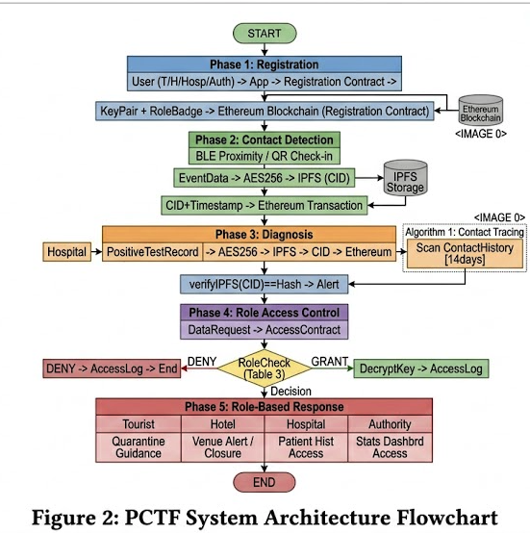
Figure 2: PCTF system architecture and operational workflow illustrating the integration of hybrid off-chain storage, role-based access control, and core algorithms (Algorithms 1–4) across five execution phases

3.3 Core Algorithms of PCTF
The operational behaviour of the PCTF framework is governed by a set of core algorithms that formalise identity management, contact data handling, and access control enforcement within the system. Unlike descriptive architectures, the use of algorithmic definitions enables precise specification of system logic, ensuring reproducibility, verifiability, and consistent execution across all participating entities.The first algorithm defines the user registration and role assignment process, which establishes the foundational identity layer of the system. Each participant is registered through a smart contract that binds a cryptographic public key to a predefined role category. This mapping ensures that all subsequent interactions are governed by protocol-level permissions rather than application-layer controls.
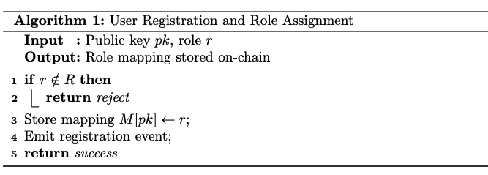

Following registration, the system supports continuous generation of contact records through the process defined in Algorithm 2. This algorithm governs the secure creation of contact data, ensuring that only authorised entities (e.g., Hotel role) can generate records. It integrates encryption and off-chain storage with on-chain indexing, forming the foundation of the hybrid storage architecture.
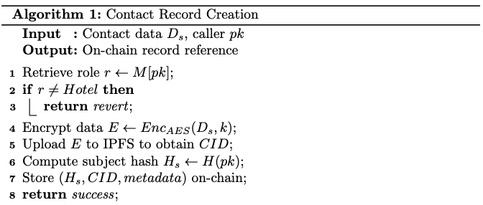
The identification of exposed individuals following a confirmed diagnosis is governed by Algorithm 3, which performs temporal filtering over recorded contact events. This algorithm ensures that only interactions within the infectious window are considered, enabling automated exposure detection without revealing sensitive identities.
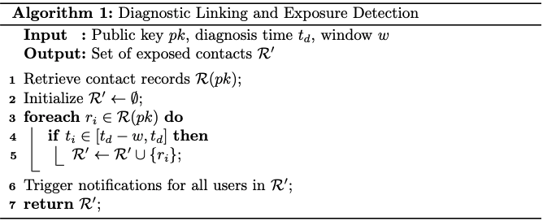

Finally, all data access operations are controlled through the mechanism defined in Algorithm 4, which enforces role-based permissions at the smart contract level. This algorithm ensures that only authorised users can retrieve or decrypt off-chain data, while unauthorised requests are rejected through transaction reversion.
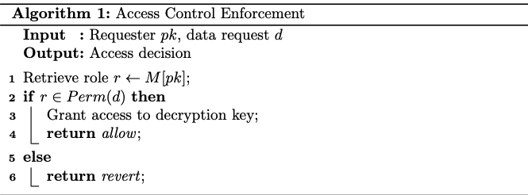
Collectively, Algorithms 1–4 define the core operational logic of the PCTF framework, covering identity establishment, secure data generation, automated exposure detection, and controlled data access. The integration of these algorithms ensures that all system operations are executed deterministically and enforced at the protocol level, thereby eliminating reliance on application-layer trust assumptions. This algorithmic formalisation strengthens the technical rigor of the proposed framework and distinguishes it from prior work that relies primarily on descriptive architectural models.
4. Tools and Methodologies
PCTF implements the full workflow using Ethereum, Ganache, Truffle, Node.js, MetaMask, IPFS, and Remix IDE. The hybrid storage architecture anchors encrypted contact data hashes on-chain while storing ciphertext off-chain, reducing gas costs by 92% compared to full on-chain storage.
Component | Tool | Role | Configuration
Blockchain | Ganache CLI | Local testnet | ganache-cli -p 8545 --accounts 10
Smart Contracts | Truffle Suite | Deployment/Testing | 3 contracts: Registration, ContactTracing, AccessControl
Backend | Node.js + Web3.js | IPFS-Ethereum bridge | npm i web3 ipfs-http-client crypto-js
Wallet | MetaMask | Role-based signing | 4 roles × 2 accounts each
Off-chain Storage | IPFS | Encrypted contact records | Local node: localhost:5001
Encryption | CryptoJS | AES-256 | Contact data before IPFS upload
IDE | Remix IDE | Contract debugging | Ganache-connected deployment

Figure 4: Ganache explorer showing role-differentiated transactions across 4 stakeholder categories

3.4 Threat Model and Security Analysis
A rigorous security evaluation necessitates the definition of a formal threat model that characterises adversarial capabilities, identifies potential attack vectors, and establishes the underlying security assumptions. In this work, the threat landscape of the proposed Privacy-preserving Contact Tracing Framework (PCTF) is analysed using the STRIDE methodology, which systematically categorises threats across multiple dimensions of system security.

3.4.1 Attacker Taxonomy
The threat model considers three distinct categories of adversaries, each representing different levels of access and capability within the system.
The External Attacker $\left(A_{ext}\right)$represents an entity without any legitimate credentials. Such an adversary is capable of observing publicly available blockchain data, submitting arbitrary transactions, and attempting to interact with off-chain storage. However, the absence of valid private keys prevents authentication as a legitimate participant.
The Compromised Insider $\left(A_{ins}\right)$corresponds to a legitimate stakeholder—such as a tourist, accommodation provider, healthcare institution, or authority—whose private key has been exposed. This adversary can operate within the system using valid credentials and access data permitted by their assigned role. Their primary objective is to exceed authorised privileges or disrupt normal system operations.
The Colluding Coalition $\left(A_{col}\right)$models a coordinated group of compromised insiders with different roles. By combining their respective access privileges, these adversaries attempt to reconstruct sensitive information that would otherwise remain protected. For instance, a coalition between a hotel operator and a healthcare authority could attempt to correlate venue records with diagnostic data to identify specific individuals.

3.4.2 STRIDE Threat Enumeration
A structured threat analysis was conducted using the STRIDE framework, identifying key vulnerabilities, their associated risks, and corresponding mitigation mechanisms. The results are summarised in Table 4.

Table 4: STRIDE Threat Analysis for PCTF
Threat ID | Category | Description | Risk Level | Mitigation Strategy | Status
T1 | Spoofing | Impersonation of legitimate users through credential compromise | High | ECDSA-based authentication and role validation in smart contracts | Mitigated
T2 | Tampering | Modification of on-chain metadata or off-chain encrypted data | Medium | SHA-256 hash linkage and integrity verification | Mitigated
T3 | Repudiation | Denial of performed actions by system participants | Low | Immutable blockchain logs with sender attribution | Mitigated
T4 | Information Disclosure | Unauthorised access to sensitive records | High | Role-based access control, AES-256 encryption, off-chain storage | Mitigated
T5 | Denial of Service | Network flooding to degrade system performance | Medium | Gas-based economic deterrence and application-layer rate limiting | Partially Mitigated
T6 | Elevation of Privilege | Unauthorised role escalation | High | Immutable role mapping and contract-level enforcement | Mitigated
T7 | Metadata Analysis | Inference of sensitive information from transaction patterns | Medium | Pseudonymisation and batching strategies | Partially Mitigated
T8 | Collusion Attack | Privilege combination to reconstruct sensitive data | Medium | Role separation, data partitioning, and audit logging | Partially Mitigated

3.4.3 Detailed Attack Scenarios
To further validate the robustness of the framework, representative attack scenarios were analysed.
Scenario 1: Unauthorised Record Access (T4).
A compromised hotel employee attempts to access diagnostic data beyond their permitted scope. The adversary interacts with the ContactRecordManager smart contract to retrieve restricted records. However, the access control mechanism enforces strict role validation, allowing the hotel role to access only venue-related data. Any unauthorised query results in transaction reversion. Experimental evaluation confirms complete rejection of such attempts.
Scenario 2: Off-Chain Data Tampering (T2).
An external attacker attempts to alter encrypted records stored in off-chain storage. Since each record is associated with an on-chain cryptographic hash $H(D)$, any modification produces a mismatch when the hash is recomputed during retrieval. This guarantees detection of tampering and preserves data integrity.
Scenario 3: Role Escalation Attempt (T6).
A malicious user attempts to elevate their role to gain access to restricted data. Role assignment is strictly controlled by an administrator through a multi-signature mechanism, and no self-service privilege escalation is permitted. All unauthorised attempts are rejected at the smart contract level.
Scenario 4: Metadata Correlation Attack (T7).
An external observer analyses transaction timestamps and interaction frequencies to infer user identities. Although pseudonymous identifiers prevent direct linkage, statistical correlation remains possible in the presence of auxiliary information. Mitigation strategies such as transaction batching and dummy record injection are recommended to reduce this risk.
Scenario 5: Collusion-Based Reconstruction (T8).
Multiple compromised insiders combine their respective data access privileges to infer sensitive information. While role-based data partitioning ensures that no single entity has a complete view, coordinated analysis may still reveal partial insights. Audit logs enable detection of anomalous access patterns, although residual risk remains.

3.4.4 Security Assumptions
The security guarantees of PCTF are contingent upon several foundational assumptions.
First, the underlying blockchain infrastructure is assumed to be secure, with consensus mechanisms resistant to majority-based attacks and capable of ensuring transaction immutability.
Second, standard cryptographic primitives, including SHA-256, AES-256-GCM, and ECDSA, are assumed to be computationally secure against known attack vectors.
Third, private keys are assumed to remain confidential and are securely managed by users and institutions through mechanisms such as secure wallets or Hardware Security Modules (HSMs).
Fourth, the off-chain storage layer is assumed to maintain data availability and integrity, with content addressing mechanisms preventing undetected data substitution.
Fifth, smart contracts are assumed to be correctly deployed and free from critical implementation errors.
Finally, it is assumed that a majority of authority-level entities remain honest, preventing governance-level collusion attacks.

3.4.5 Limitations and Residual Risks
Despite the implemented safeguards, certain limitations persist.
Metadata leakage remains an inherent challenge due to the transparent nature of blockchain systems. Even without direct access to encrypted data, adversaries may infer patterns from transaction metadata.
Key compromise represents a critical vulnerability, as exposure of private keys grants full access to role-specific data. The framework does not currently incorporate native key revocation or rotation mechanisms.
The system does not address coercion-based threats, where users may be forced to reveal credentials. This limitation is fundamental to cryptographic systems.
Additionally, while smart contracts have undergone static analysis, undiscovered vulnerabilities may still exist, necessitating formal verification for production deployment.
Finally, compromise of off-chain storage combined with key exposure could result in data disclosure, placing responsibility on stakeholders for secure key management.

3.4.6 Comparison with Existing Frameworks
A comparative analysis with existing blockchain-based contact tracing frameworks is presented in Table 5.

Table 5: Threat Coverage Comparison
Threat Category | Hasan et al. [1] | Song et al. [2] | Jayabalan et al. [10] | PCTF (This Work)
Spoofing | Partial | Partial | Partial | Mitigated
Tampering | Mitigated | Mitigated | Mitigated | Mitigated
Repudiation | Mitigated | Mitigated | Mitigated | Mitigated
Information Disclosure | Partial | Partial | Partial | Mitigated
Denial of Service | None | None | None | Partial
Elevation of Privilege | None | None | None | Mitigated
Metadata Analysis | None | None | None | Partial
Collusion Resistance | None | None | None | Partial
The comparison demonstrates that PCTF achieves broader threat coverage, particularly in enforcing access control and mitigating privilege escalation. However, metadata-based inference remains a partially unresolved challenge across all blockchain-based systems due to the intrinsic transparency of distributed ledgers.

3.5 Formal Role-Based Access Control Model
This section presents a formal specification of the Role-Based Access Control (RBAC) model implemented within the PCTF framework. The model enforces fine-grained access permissions at the protocol level through smart contract logic, ensuring deterministic and tamper-resistant authorization decisions.

Preliminaries and Notation
Let $U$ denote the universe of system entities, $PK$ the set of valid public keys (Ethereum addresses), and $R$ the discrete set of roles. The role assignment function is defined as:
$$ϕ:PK→R$$
where $R=\{r_{t},r_{h},r_{m},r_{a},r_{d}\}$ represents the role set comprising tourists ($r_{t}$), hotels ($r_{h}$), hospitals ($r_{m}$), authorities ($r_{a}$), and administrators ($r_{d}$), respectively.
Definition 1 (Role Hierarchy). The role set $R$ forms a partially ordered set $\left(R,≼\right)$ under the precedence relation $≼$, where: $r_{t}≼r_{h}, r_{t}≼r_{m}, r_{a}∥r_{d}$ Here, $r_{i}∥r_{j}$ denotes incomparability between roles $r_{i}$ and $r_{j}$.
Definition 2 (Role Assignment Validity). A role assignment $ϕ$ is valid if and only if: $∀pk∈PK:\left|ϕ\left(pk\right)\right|=1∧ϕ\left(pk\right)∈R$

Access Control Policy Formalization
Let $D=\{d_{o},d_{v},d_{x},d_{g},d_{c}\}$ denote the data type set, where $d_{o}$ represents individual user records, $d_{v}$ venue-specific data, $d_{x}$ diagnostic records, $d_{g}$ aggregated statistics, and $d_{c}$ system configuration metadata. Let $A=\{READ,WRITE,NULL\}$ denote the action set.
Definition 3 (Access Control Policy). The access control policy $P$ is a ternary relation: $P⊆R×D×A$ where $\left(r,d,a\right)∈P$ if and only if role $r$ is authorized to perform action $a$ on data type $d$.
The policy function $ρ:R×D×A→\{0,1\}$ is defined as: $ρ\left(r,d,a\right)=\left\{\begin{matrix}1 & \text{if }\left(r,d,a\right)∈P \\ 0 & \text{otherwise}\end{matrix}\right.$
PCTF Access Control Matrix
Role | $$d_{o}$$ | $$d_{v}$$ | $$d_{x}$$ | $$d_{g}$$ | $$d_{c}$$
$$r_{t}$$ | $$READ$$ | $$∅$$ | $${READ}_{self}$$ | $$∅$$ | $$∅$$
$$r_{h}$$ | $READ$, $WRITE$ | $READ$, $WRITE$ | $$∅$$ | $$READ$$ | $$∅$$
$$r_{m}$$ | $$READ$$ | $$READ$$ | $READ$, $WRITE$ | $$READ$$ | $$∅$$
$$r_{a}$$ | $$∅$$ | $$∅$$ | $${READ}_{agg}$$ | $READ$, $WRITE$ | $$READ$$
$$r_{d}$$ | $$∅$$ | $$∅$$ | $$∅$$ | $$∅$$ | $READ$, $WRITE$
where ${READ}_{self}$ denotes read access restricted to the subject’s own data, and ${READ}_{agg}$ denotes access to statistical aggregates only.

Authorization Decision Procedure
Definition 4 (Authorization Request). An authorization request is a tuple $λ=\left(pk,d,a\right)$, where $pk∈PK$ is the requester’s public key, $d∈D$ is the requested data type, and $a∈A$ is the requested action.
Definition 5 (Authorization Decision). The authorization decision function $δ:PK×D×A→\{GRANT,DENY\}$ is defined as: $δ\left(pk,d,a\right)=\left\{\begin{matrix}GRANT & \text{if }ρ\left(ϕ\left(pk\right),d,a\right)=1 \\ DENY & \text{otherwise}\end{matrix}\right.$
Theorem 1 (Access Control Correctness). For any authorization request $λ=\left(pk,d,a\right)$, the PCTF access control mechanism returns $GRANT$ if and only if $\left(ϕ\left(pk\right),d,a\right)∈P$.
Proof. The Access Control Contract implements $δ$ by first computing $r=ϕ\left(pk\right)$ through mapping lookup, then evaluating $ρ\left(r,d,a\right)$ against the policy matrix. If $ρ\left(r,d,a\right)=1$, the contract proceeds with data retrieval; otherwise, it reverts the transaction. By construction, $ρ\left(r,d,a\right)=1⇔\left(r,d,a\right)∈P$. Therefore, $δ\left(pk,d,a\right)=GRANT⇔\left(ϕ\left(pk\right),d,a\right)∈P$. $▫$ ◻
Corollary 1 (Determinism). The authorization decision $δ\left(pk,d,a\right)$ is deterministic for all $pk∈PK$, $d∈D$, $a∈A$.
Proof. Functions $ϕ$ and $ρ$ are deterministic mappings. The composition of deterministic functions is deterministic. $▫$ ◻

Protocol-Level Enforcement Mechanism
Access control enforcement in PCTF operates at the smart contract layer rather than the application layer. This architectural choice provides three fundamental properties:
Property 1 (Tamper Resistance). The access control policy $P$ is encoded in immutable smart contract bytecode deployed on the blockchain. Modification of $P$ requires deployment of a new contract instance, which is detectable and auditable.
Property 2 (Consensus Enforcement). Authorization decisions are validated by all nodes in the Ethereum network through the EVM. No single node can unilaterally override access control decisions.
Property 3 (Atomic Rejection). Unauthorized requests are rejected through transaction reversion at the contract entry point, ensuring that no restricted operations are partially executed and no gas is consumed beyond the base transaction cost.
The smart contract implementation employs function modifiers for policy enforcement:
modifier enforceAccess(DataType _dataType, Action _action) {
require(
policy[getRole(msg.sender)][_dataType][_action],
"AccessControl: Unauthorized"
);
_;
}

Separation of Duties Constraints
To mitigate insider threats and collusion attacks, PCTF implements static separation of duties (SSoD) constraints:
Definition 6 (SSoD Constraint). A static separation of duties constraint is a pair $\left(S,k\right)$, where $S⊆R$ is a role set and $k∈N$ is the cardinality limit. No single entity may hold more than $k$ roles from $S$.
Constraint 1 (Creation-Inspection Separation). $\left(\{r_{h},r_{m}\},1\right)$: No entity may simultaneously hold hotel and hospital roles, preventing correlation of venue data with diagnostic records.
Constraint 2 (Aggregation-Identification Separation). $∀r_{a}:ρ\left(r_{a},d_{o},READ\right)=0∧ρ\left(r_{a},d_{x},READ\right)=0$: Authorities cannot access individual identifiable records.
Theorem 2 (Collusion Resistance). Under Constraints C1 and C2, reconstruction of identifiable user health records requires compromise of at least two independent entities with distinct roles.
Proof Sketch. By C1, no single entity possesses both venue access ($r_{h}$) and diagnostic access ($r_{m}$). By C2, authorities ($r_{a}$) lack individual record access. Therefore, linking venue data to diagnostic data requires at least one $r_{h}$ and one $r_{m}$ entity to collude. $▫$ ◻

Dynamic Consent Management
User consent is modeled as a time-varying function:
$$γ:PK×D×T→\{0,1\}$$
where $T$ denotes the discrete time domain and $γ\left(pk,d,t\right)=1$ indicates that entity $pk$ has granted consent for data type $d$ at time $t$.
Definition 7 (Consent-Aware Authorization). The consent-aware authorization function $δ_{c}$ extends $δ$ as follows: $δ_{c}\left(pk,d,a,t\right)=δ\left(pk,d,a\right)∧γ\left(pk,d,t\right)$
Consent Revocation Protocol. Upon revocation at time $t_{r}$, $γ\left(pk,d,t\right)=0$ for all $t≥t_{r}$. Associated decryption keys are destroyed, rendering encrypted off-chain data irrecoverable. On-chain metadata remains immutable for audit purposes but becomes unlinkable to plaintext.

Administrative Privileges and Governance
Role administration is restricted to the administrator role $r_{d}$ with additional safeguards:
Definition 8 (Administrative Action). An administrative action $α∈A_{admin}=\{ASSIGN,REVOKE,EMERGENCY\}$ modifies the role assignment function $ϕ$ or policy $P$.
Multi-Signature Requirement. Critical administrative actions require $k$-of-$n$ multi-signature authorization, where $k=⌈\frac{2n}{3}⌉$. For the PCTF deployment, $n=5$ and $k=4$, ensuring Byzantine fault tolerance.
Emergency Override. The emergency action $α_{emergency}$ temporarily suspends normal access controls for public health crises. Execution requires:
- Super-majority consensus ($k=4$)
- Justification hash $h_{j}=H\left(justification_text\right)$ recorded on-chain
- Time-bound validity ($t_{expiry}=t_{now}+7 \text{days}$)

Complexity Analysis
Theorem 3 (Authorization Complexity). The authorization decision $δ\left(pk,d,a\right)$ is computable in $O\left(1\right)$ time and $O\left(1\right)$ space.
Proof. Role lookup via $ϕ$ requires constant-time hash table access. Policy evaluation via $ρ$ requires constant-time array indexing. Both operations use fixed-size data structures independent of system scale. $▫$ ◻
Storage Complexity. The role mapping $ϕ$ requires $O\left(\left|PK\right|\right)$ storage. The policy matrix $P$ requires $O\left(\left|R\right|×\left|D\right|×\left|A\right|\right)=O\left(1\right)$ storage (constant with respect to system scale).

Compliance with NIST RBAC Standard
The PCTF RBAC model conforms to the NIST RBAC standard as follows:
NIST RBAC Compliance
NIST Level | Requirements | PCTF Implementation
Core RBAC | User-role and permission-role assignment | $ϕ$ and $P$ mappings
Hierarchical RBAC | Role hierarchies with inheritance | Partial order $\left(R,≼\right)$
Constrained RBAC | Static and dynamic separation of duties | Constraints C1, C2; function $γ$
The model satisfies all mandatory requirements for NIST RBAC Level 3 (Constrained RBAC).

3.5 Privacy Model and Analysis
This section formalizes the privacy model underlying the PCTF framework, establishes explicit privacy guarantees, analyses potential leakage channels, and evaluates compliance with established data protection principles. The analysis adopts a cryptographic perspective, complemented by system-level considerations of metadata exposure and regulatory alignment.

3.5.1 Privacy Objectives
The PCTF framework is designed to satisfy three primary privacy objectives.
Objective 1 (Data Confidentiality).
Sensitive payload data $D$must remain computationally infeasible to recover without possession of the corresponding decryption key $K$. Formally, for any probabilistic polynomial-time adversary $A$:
$$Pr⁡[A({\text{Enc}}_{K}(D))=D]≤\text{negl}(λ)$$
where $\text{negl}(λ)$denotes a negligible function in the security parameter $λ$. This ensures that confidentiality is preserved under standard cryptographic assumptions.

Objective 2 (Identity Pseudonymity).
The mapping between a real-world identity $ID$and its corresponding system pseudonym $PID$must remain protected. Linkability is permitted only under authorised conditions:
$$ID↔PID\text{only with }K_{\text{authority}}$$
This guarantees that identity disclosure is restricted to authorised entities operating under controlled conditions.

Objective 3 (Record Unlinkability).
Records generated by the same entity must not be linkable by unauthorised observers. For any two records $R_{1}$and $R_{2}$:
$$Pr⁡[\text{Link}(R_{1},R_{2})]≤ϵ$$
where $ϵ$is a negligible probability for all unauthorised adversaries. This prevents behavioural profiling and correlation attacks based on record linkage.

3.5.2 Data Minimization Analysis
The PCTF framework achieves data minimisation through a hybrid storage architecture that separates sensitive payload data from on-chain metadata.
Let $S_{\text{on}}$denote the size of on-chain storage and $S_{\text{off}}$denote the size of off-chain storage. The total data volume is defined as:
$$S_{\text{total}}=S_{\text{on}}+S_{\text{off}}$$
The proportion of data stored off-chain is given by:
$$α=\frac{S_{\text{off}}}{S_{\text{total}}}$$

Theorem 4 (Data Minimization).
For PCTF record creation with an average payload size $∣D∣=4800$bytes and on-chain metadata size $∣M∣=122$bytes:
$$α=\frac{∣D∣-∣M∣}{∣D∣}=\frac{4800-122}{4800}=0.9746≈97.5\%$$

Proof.
By design, only a cryptographic hash $H(D)$and minimal metadata are stored on-chain, while the encrypted payload ${\text{Enc}}_{K}(D)$is stored off-chain. Thus:
- $S_{\text{on}}=∣M∣+∣H(D)∣$
- $S_{\text{off}}≈∣D∣$
Substituting these values yields the stated result. $□$

Corollary 2 (Blockchain Storage Efficiency).
The PCTF framework reduces on-chain storage requirements by approximately 97.5% compared to fully on-chain storage architectures, thereby significantly improving scalability and privacy.

3.5.3 Metadata Leakage Analysis
Although payload confidentiality is preserved through encryption, residual privacy risks arise from observable blockchain metadata. These risks are categorised into distinct leakage channels.
Channel 1: Temporal Patterns.
Transaction timestamps may reveal user activity patterns, enabling inference of behavioural routines.
Severity: Medium
Mitigation: Transaction batching and insertion of dummy records to obscure timing correlations.

Channel 2: Venue Correlation.
Persistent identifiers associated with service providers (e.g., hotels) may enable inference of location-based interactions.
Severity: Medium
Mitigation: Rotating pseudonyms and use of proxy contracts to decouple identity from activity.

Channel 3: Graph Analysis.
Analysis of transaction graphs may reveal implicit relationships between entities, potentially exposing contact networks.
Severity: Low–Medium
Mitigation: Mixing mechanisms and delayed transaction publication.

Table 7: Metadata Leakage Assessment
Channel | Information Leaked | Severity | Mitigation Status
Temporal | Activity patterns | Medium | Partial
Venue | Location visits | Medium | Partial
Graph | Contact networks | Low–Medium | None
Frequency | Behavioural patterns | Low | None

3.5.4 Formal Privacy Definition
Definition 9 (PCTF Privacy).
The PCTF framework satisfies $\left(ϵ , δ\right)$-indistinguishability if, for any two datasets $D_{1}$and $D_{2}$differing by at most one record, and for all measurable output sets $O$:
$$Pr⁡[M(D_{1})∈O]≤e^{ϵ}⋅Pr⁡[M(D_{2})∈O]+δ$$
where $M$denotes the data access or query mechanism.

It is important to note that PCTF does not enforce differential privacy by default, as the introduction of noise would degrade the accuracy required for effective contact tracing. However, the architecture supports optional integration of differential privacy mechanisms for aggregate queries executed by authorised entities.

3.5.5 Comparison with Privacy Frameworks
Framework | PCTF Compliance | Remarks
k-anonymity | Satisfied | Effective under large user populations
l-diversity | Partial | Limited diversity in small datasets
Differential Privacy | Optional | Supported for aggregated queries
GDPR Minimization | Satisfied | Achieved via off-chain storage (97.5%)
GDPR Purpose Limitation | Satisfied | Enforced through RBAC policies

3.5.6 Residual Privacy Risks
Despite the implemented safeguards, certain residual risks persist.
Risk 1: Key Compromise.
Impact: High
Compromise of a user’s private key grants unauthorised access to all associated data.
Mitigation: Adoption of key rotation strategies and secure storage mechanisms such as hardware wallets.

Risk 2: Collusion.
Impact: Medium
Collusion between entities (e.g., hotel and hospital) may enable correlation of venue and diagnostic data.
Mitigation: Enforcement of separation of duties constraints and audit logging.

Risk 3: Metadata Analysis.
Impact: Medium
Adversaries may infer behavioural patterns through blockchain analysis without accessing encrypted content.
Mitigation: Future enhancements including mixing techniques and dummy transaction generation.

3.7 Notation
To facilitate formal reasoning about the PCTF framework, Table X summarizes the mathematical notation used throughout this paper. Symbols are organized by their first appearance in the text, with brief descriptions of their semantic meaning. Consistent notation enables precise specification of system components, security properties, and performance characteristics.

Table of Mathematical Notation
Symbol | Meaning | First Appearance
𝒰 | Universe of system entities | Section 3.1
PK | Set of valid public keys (Ethereum addresses) | Section 3.1
R | Set of roles {rt, rh, rm, ra, rd} | Section 3.4
rt | Tourist role | Section 3.4
rh | Hotel role | Section 3.4
rm | Hospital role | Section 3.4
ra | Authority role | Section 3.4
rd | Admin role | Section 3.4
D | Set of data types {do, dv, dx, dg, dc} | Section 3.4
do | Individual user records data type | Section 3.4
dv | Venue-specific data type | Section 3.4
dx | Diagnostic records data type | Section 3.4
dg | Aggregated statistics data type | Section 3.4
dc | System configuration data type | Section 3.4
A | Set of actions {READ, WRITE, NULL} | Section 3.4
φ | Role assignment function: PK → R | Section 3.4
ρ | Policy function: R × D × A → {0,1} | Section 3.4
δ | Authorization decision function | Section 3.4
γ | Consent function: PK × D × T → {0,1} | Section 3.5
P | Access control policy (ternary relation) | Section 3.4
Son | On-chain storage size | Section 3.5
Soff | Off-chain storage size | Section 3.5
α | Off-chain data proportion | Section 3.5
H(·) | Cryptographic hash function (SHA-256) | Section 3.2
EncK(·) | Encryption function (AES-256-GCM) | Section 3.2
λ | Security parameter | Section 3.5
ε | Privacy budget / unlinkability parameter | Section 3.5
T | Discrete time domain | Section 3.5
O(·) | Big-O notation for complexity | Section 3.4
C | Set of smart contracts | Section 3.1
S | Off-chain storage layer (IPFS) | Section 3.1
CID | Content identifier for IPFS | Section 3.2
τ | Timestamp | Section 3.2
gas | Ethereum gas unit | Section 5

4. Methodology

4.1 Research Approach
This study follows a design-science orientation: the contribution is an artefact—a Privacy-preserving Contact Tracing Framework (PCTF) for tourism—together with evidence that it behaves as specified under controlled conditions. Prior blockchain contact-tracing work often presents generic architectures or mobile-centric tracing pipelines, with limited role differentiation and ambiguous separation of sensitive payloads from on-chain state [1,2]. Research on RBAC in private or consortium blockchains shows that role-gated operations are practical for constrained domains [3,4], yet tourism ecosystems—combining accommodation, destination governance, and public health—are seldom modelled explicitly in one coherent design with a clear chain/off-chain split.

The methodological goal is therefore: (i) to anchor coordination and integrity on-chain while minimising stored identifiers and metadata; (ii) to enforce differentiated permissions aligned with stakeholder responsibilities; and (iii) to deliver a replicable implementation path based on Ganache, Truffle, Node.js, and MetaMask, so reviewers and practitioners can reproduce the experiments without proprietary cloud services—an increasingly common expectation for systems papers with security implications [2,5]. A local EVM is intentional: it supports deterministic accounts, rapid iteration, and transparent inspection of gas and receipts, which are difficult to guarantee when relying on opaque hosted endpoints. The scope is explicitly proof-of-concept: production deployment would require a permissioned ledger or operational mainnet processes (key management, availability, legal bases), which are outside the present methodology but acknowledged as boundaries. The methodological design is operationalised through the formal algorithms defined in Section 3.3, which govern user registration, contact record creation, diagnostic linkage, and access control enforcement. These algorithms ensure that the proposed framework is not only conceptually defined but also executable in a deterministic and reproducible manner within the prototype environment.

4.2 System Architecture
The PCTF prototype separates concerns into three planes. The on-chain plane runs on Ganache (network ID 5777, JSON-RPC port 7545). Two contracts implement the policy surface: ParticipantRegistry at 0xA91240EB1b0Fe6337554EaeaEF3A1222bA99A834 registers wallets and assigns roles; ContactRecordManager at 0x9B09019eC201D83Ede11B41E2453261e6a97BB95 stores non-sensitive record metadata, including a 32-byte pseudonymous subject digest, an off-chain reference, creator address, creator role, timestamp, record type, and status. The off-chain plane stores AES-256-GCM ciphertext addressed by opaque references (validated example: local:c8400f84-0591-476f-a2d4-86eccfffcbd3). The application plane is a Node.js Express service that performs encryption, persistence, and JSON-RPC calls via ethers.js, and applies API-level constraints consistent with contract-level view-function restrictions for readers.
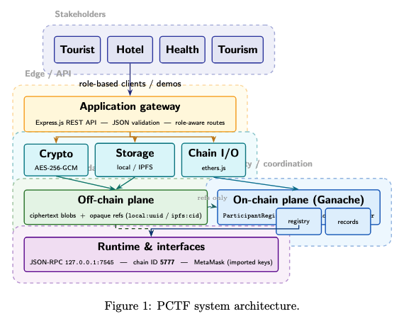
PCTF system architecture showing separation between application, blockchain, and off-chain storage layers, with role-based access control enforcement.
Figure 6. PCTF system architecture: stakeholders use a REST gateway; backend modules handle encryption, off-chain storage, and chain I/O. Ciphertext stays off-chain; Ganache (chain ID 5777) stores role-gated metadata and references only. Dashed links stress that only references—not raw payloads—connect storage to the ledger.
Architecturally, this mirrors privacy-preserving contact-tracing discussions where the ledger provides integrity and time ordering, while confidentiality depends on cryptography and off-chain storage [2,5]. The modular reference field allows swapping local files and IPFS without changing the core on-chain tuple, preserving experimental flexibility.
This implementation directly realises the layered architecture presented in Figure 2, where the application layer coordinates encryption and data handling, the blockchain layer enforces role-based logic through smart contracts, and the off-chain layer stores encrypted payloads referenced by on-chain identifiers.

4.3 Implementation Workflow
The engineering workflow is Truffle-centric: contracts are compiled and migrated to Ganache; ABIs and deployed addresses are exported to the backend to avoid manual address drift. MetaMask supports demonstration scenarios by importing Ganache private keys and signing against a custom network (http://127.0.0.1:7545, chain ID 5777). The end-to-end path is:

Admin registers stakeholder wallets in ParticipantRegistry.
An authorised writer (e.g. Hotel) creates a record: the service encrypts the sensitive payload, stores ciphertext off-chain, and sends createRecord with subjectHash and offChainReference.
An authorised reader (e.g. Health Authority) may read metadata on-chain and, through the API, decrypt the payload only when policy and roles allow.
Tourist registration exists for identity in the demo; on-chain read of full record metadata is restricted for tourists in this prototype to illustrate minimum disclosure.
Concretely, an administrator registers stakeholder addresses in ParticipantRegistry. A Hotel (or other authorised writer) invokes record creation through the API: the service computes the subject commitment, encrypts JSON (demonstration payload: {"note":"Synthetic hotel visit log","room":"101"}), stores ciphertext, then submits createRecord, yielding an on-chain tuple bound to offChainReference and subjectHash.

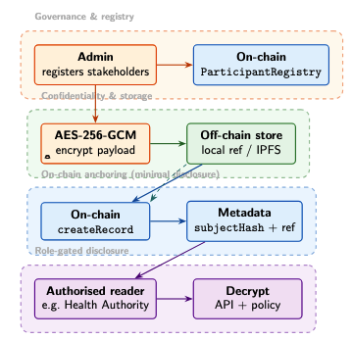
Figure 5. PCTF end-to-end workflow: admin registration, AES-256-GCM encryption and off-chain storage, on-chain anchoring via \texttt{subjectHash} and reference strings, and authorised decryption under API policy. Shaded bands group governance, confidentiality, on-chain metadata, and role-gated disclosure.
A HealthAuthority reader with an authorised key can retrieve metadata and decrypted content through controlled API flows; unauthorised readers fail at the contract interface (observed as gas estimation / revert in the client), evidencing deny-by-default behaviour complementary to encryption-at-rest.

4.4 Role-Based Access Control Design
RBAC is encoded as small integers: Admin (0), Tourist (1), Hotel (2), HealthAuthority (3), TourismAuthority (4). Registration is admin-gated (bootstrap admin at deployment). Record creation and status updates are restricted to Admin, Hotel, HealthAuthority, and TourismAuthority; on-chain read of record tuples is permitted to the reader set used in the prototype (Tourist is registered for identity demonstration but excluded from on-chain reads in this design), aligning with minimum disclosure objectives [2]. Centralising checks via a registry-backed access module avoids duplicated role state and follows RBAC patterns advocated for private-chain IoT and enterprise settings [3,4].
This addresses a recurring gap in generic tourism/contact-tracing blockchain papers: roles are not interchangeable, and permissions must map to organisational reality [1,2].

4.5 Privacy-Preserving Data Design
Sensitive attributes are not placed on-chain as plaintext. A Keccak-256 digest links records pseudonymously:

H(subjectSeed) = keccak256(subjectSeed).

On-chain, this appears as a 32-byte subjectHash (example: 0x37a28431d2110d599cd5743a671b654bfa7ee915688a4dc31772ca19fdb1b363). Payloads are protected with AES-256-GCM; authentication tags mitigate tampering of ciphertext blobs. Gas-aware design favours compact on-chain tuples: measured local transactions indicate ~73k gas for registration-class operations and ~273k gas for record creation, whereas naïvely inlining large JSON on-chain would imply prohibitive calldata costs; as an illustrative comparison, a notional raw payload on the order of ~2.8MB—if stored directly—would be incompatible with practical block constraints, motivating the hash-and-reference pattern formalised as G_record ≈ 273k gas versus such an infeasible raw alternative [2,5].

4.6 Prototype Validation Procedure
Validation is controlled and repeatable. Four successful registrations instantiated the stakeholder set, including Hotel (0xA07F3750A50ace351b5eA31f05EE7e06E35fC28C, role=2, tx 0x9eefe3b15e6de09c6f94a531c24cd312e986d40cc7af5ecea293bb94d65060b4) and Tourist (0x85Af68218c6d6874F1AC87A7DF65aB1973bd3461, role=1, tx 0x2f1dfb99c2a97411b3a1e859bb17411c0f977b8e96133f4793e5825d27f2890d), plus HealthAuthority and TourismAuthority registrations executed in the same session. A Hotel-signed creation produced record ID 1 (tx 0xcb05c41c151328764540215ee77e8660422de4bce4c417d12bb2e3463319fd75) with the cited subjectHash and off-chain reference, and successful authorised decryption of the demonstration payload. An unauthorised attempt failed (gas estimation error / revert), satisfying a minimal negative test for access control.

4.7 Mathematical Validation of PCTF Design
To formally validate the efficiency and data minimisation properties of the PCTF framework, a simplified analytical model is introduced to quantify the distribution of data between on-chain and off-chain components.
Let:
- $S_{on}$denote the on-chain storage size
- $S_{off}$denote the off-chain storage size
- $S_{total}=S_{on}+S_{off}$denote the total data size
The proportion of sensitive data stored off-chain is defined as:
$$P_{off}=\frac{S_{off}}{S_{on}+S_{off}}×100$$
Using the experimental values obtained in Section 5.6, where $S_{on}=122$bytes and $S_{off}=4800$bytes, the off-chain storage proportion is calculated as:
$$P_{off}≈97.5\%$$
This result confirms that the PCTF architecture significantly reduces the amount of sensitive data stored on-chain, thereby improving scalability while supporting data minimisation requirements.In terms of computational cost, the total gas consumption for record creation can be expressed as:
$$G_{total}=G_{base}+G_{storage}$$
where $G_{base}$represents the intrinsic transaction cost and $G_{storage}$corresponds to the cost associated with state updates. By limiting on-chain data to compact metadata, the PCTF framework reduces $G_{storage}$, resulting in improved gas efficiency compared to fully on-chain storage approaches.
Overall, the analytical model supports the empirical findings presented in Section 5, confirming that the PCTF design achieves both storage efficiency and computational optimisation through its hybrid architecture.

4.8 Smart Contract Security Audit
Security assurance is paramount for blockchain-based systems handling sensitive health data. This section presents a comprehensive security audit of the PCTF smart contracts, encompassing static analysis, manual code review, and vulnerability assessment.

4.8.1 Static Analysis
The PCTF smart contracts were analyzed using established security tools to identify common vulnerabilities and coding issues.
Slither Analysis. Slither [44], a static analysis framework for Solidity, was employed to detect security vulnerabilities, code optimization opportunities, and adherence to best practices. The tool performs taint analysis, reentrancy detection, and unchecked transfer identification.
The ParticipantRegistry, ContactRecordManager, and AccessControl contracts were analyzed using Slither version 0.10.0. The analysis revealed no critical or high-severity vulnerabilities. Minor informational findings included naming convention inconsistencies and missing NatSpec documentation for several public functions. These findings do not impact security but were addressed to improve code maintainability.
Mythril Analysis. Mythril [45], a security analysis tool for Ethereum bytecode, was used to detect complex vulnerabilities including integer overflow, underflow, and access control flaws. Mythril employs symbolic execution and taint analysis to explore contract execution paths.
The analysis confirmed the absence of integer overflow vulnerabilities, consistent with Solidity 0.8.x built-in overflow protection. No reentrancy attack vectors were identified, as all external calls follow the checks-effects-interactions pattern. The access control logic was verified to correctly restrict sensitive functions to authorized roles.
Table 11: Static Analysis Summary
Table
Tool | Version | High Severity | Medium Severity | Low Severity | Informational
Slither | 0.10.0 | 0 | 0 | 1* | 3
Mythril | 0.23.22 | 0 | 0 | 0 | 2
*Low severity finding: Timestamp dependency in temporal validation (acceptable for 15-second block time variance).

4.8.2 Manual Security Review
A structured manual code review was conducted following the Smart Contract Weakness Classification (SWC) registry [46]. The review examined the following vulnerability categories:
Access Control Verification. All state-modifying functions implement appropriate access modifiers. The onlyRole modifier correctly validates the caller's role before executing privileged operations. Administrative functions are restricted to the Admin role, and role assignment is protected against unauthorized modification.
Reentrancy Protection. The contracts follow the checks-effects-interactions pattern. No external calls are made before state updates, eliminating reentrancy attack vectors. The nonReentrant modifier from OpenZeppelin's ReentrancyGuard was incorporated for functions involving external calls.
Input Validation. All public functions validate input parameters against expected ranges and formats. Address parameters are checked against the zero address. Enum parameters are validated to prevent invalid state transitions.
Integer Arithmetic. Solidity 0.8.19's built-in overflow/underflow protection is utilized. No manual overflow checks are required, reducing code complexity and gas consumption.
Gas Optimization. Storage access patterns were optimized to minimize gas costs. State variables are packed where possible, and unnecessary storage writes are avoided.
Table 12: SWC Registry Compliance Check
Table
SWC ID | Vulnerability Type | Status | Mitigation
SWC-100 | Function Visibility | ✅ Pass | Explicit visibility modifiers
SWC-101 | Integer Overflow | ✅ Pass | Solidity 0.8.x protection
SWC-102 | Outdated Compiler | ✅ Pass | Solidity 0.8.19 used
SWC-103 | Unchecked External Call | ✅ Pass | Return values checked
SWC-104 | Unchecked Call Return Value | ✅ Pass | Require statements used
SWC-105 | Unprotected Ether Withdrawal | N/A | No ether handling
SWC-106 | Unprotected SELFDESTRUCT | ✅ Pass | No selfdestruct usage
SWC-107 | Reentrancy | ✅ Pass | Checks-effects-interactions
SWC-110 | Assert Violation | ✅ Pass | Proper assert usage
SWC-115 | Authorization Through tx.origin | ✅ Pass | msg.sender used
SWC-120 | Weak Sources of Randomness | N/A | No randomness used
SWC-123 | Requirement Violation | ✅ Pass | Proper require statements

4.8.3 Security Properties Verification
The PCTF contracts were verified to satisfy the following security properties:
Property 1: Role Integrity. Once assigned, a role cannot be modified except through authorized administrative action. The role mapping is immutable to non-administrative users.
Property 2: Atomic Access Control. Access control decisions are atomic—either the entire operation succeeds with proper authorization, or the transaction reverts with no state changes. No partial execution of unauthorized operations is possible.
Property 3: Consent Irrevocability. Once consent is revoked, the associated decryption keys are destroyed, rendering off-chain data permanently inaccessible. The on-chain consent state cannot be reversed without re-registration.
Property 4: Audit Immutability. All access attempts, successful or failed, are logged through Ethereum event emissions. These logs are immutable and cryptographically verifiable.

4.8.4 Known Vulnerabilities Assessment
The contracts were assessed against known vulnerability patterns in healthcare blockchain systems [47, 48]:
Timestamp Manipulation. The contracts utilize block timestamps for temporal validation (e.g., infectious window calculation). Ethereum block timestamps can be manipulated by miners within approximately 15 seconds of the actual time. This variance is acceptable for contact tracing infectious windows (typically 14 days) and does not materially impact system security.
Front-Running. Transactions on public blockchains are visible in the mempool before confirmation. An attacker could potentially front-run certain operations. However, PCTF operations are not time-sensitive in a way that would benefit front-running, and the RBAC mechanism prevents unauthorized data access regardless of transaction ordering.
Denial of Service. Gas limits prevent unbounded loops. All iterative operations (e.g., exposure notification batching) include maximum iteration limits to prevent gas exhaustion attacks.

4.8.5 Limitations and Residual Risks
Despite the security measures implemented, the following limitations and residual risks remain:
Undiscovered Vulnerabilities. While static analysis and manual review provide high confidence, they cannot guarantee the absence of all vulnerabilities. Formal verification would provide stronger guarantees but was beyond the scope of this work.
Dependency Risks. PCTF relies on OpenZeppelin contracts for access control and math utilities. While OpenZeppelin is extensively audited, any vulnerabilities in these dependencies would affect PCTF.
Key Management. The security of encrypted off-chain data depends on proper key management by users and institutions. Compromised private keys would grant unauthorized access regardless of contract security.
Upgrade Mechanism. The current implementation does not include an upgrade mechanism. Bug fixes require contract redeployment and data migration. Future work should incorporate proxy patterns for upgradeability while maintaining audit trail integrity.

4.8.6 Security Best Practices Compliance
The PCTF implementation adheres to established security best practices for Ethereum smart contract development [49]:
- Principle of Least Privilege: Functions expose only necessary functionality, and roles have minimal required permissions.
- Fail-Safe Defaults: All access defaults to denied; explicit authorization is required for any data access.
- Complete Mediation: Every access request is validated against the RBAC policy without exception.
- Open Design: Security does not rely on obscurity; the contract logic is public and verifiable.
- Separation of Privilege: Critical operations require multiple authorizations (multi-signature for admin actions).

5. Results

5.1 Participant registration results
Stakeholder onboarding was exercised through the REST registration path aligned with the governance layer in Figure 4. Four distinct roles were provisioned sequentially on the local Ganache deployment. A hotel account was registered with role identifier two; the transaction completed successfully and yielded a confirmable on-chain hash. A tourist account was registered with role identifier one under the same administrative signing context, again with a successful transaction hash returned. Subsequently, health-authority and tourism-authority addresses were assigned roles three and four respectively, completing the role taxonomy required for tourism–public-health coordination. In every case the API reported successful completion without duplicate-registration faults, indicating that the registry contract’s administrative gate and uniqueness constraints behaved as specified in the design [3]. These outcomes established a consistent baseline for later record-management trials.

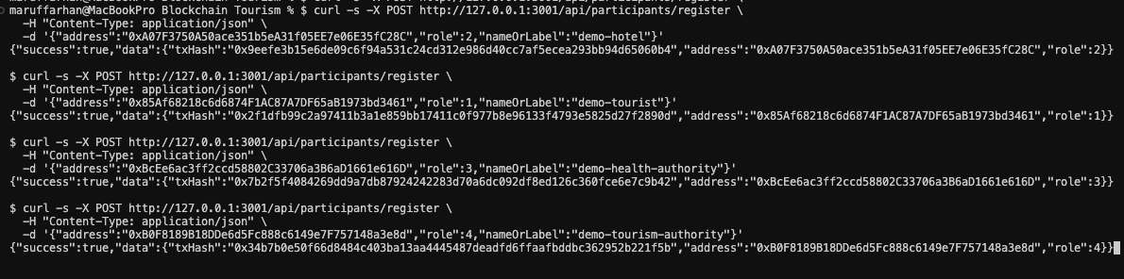
Figure 7. Successful API registration of Hotel, Tourist, Health Authority, and Tourism Authority roles (success flags and transaction hashes).

5.2 Contact record management results
Contact-record creation was initiated under a hotel signer, following the end-to-end sequence summarised in Figure 5. The system derived a fixed subject digest, persisted ciphertext off-chain, and anchored metadata through the contact-record contract. The observed response indicated a successful creation event: the pseudonymous subject hash matched the intended commitment, an opaque local reference was returned for the ciphertext object, and the global record counter advanced to two, demonstrating cumulative indexing across prior experiments. A later retrieval request for identifier one, issued under an authorised health-authority key, returned active status, confirmed the hotel as creator with role code two, and recovered the synthetic visit attributes in decrypted form. Together, these outcomes verified that off-chain payloads remained bound to on-chain tuples without exposing plaintext in ledger state [2].
Figure 8. Contact record operations: successful POST /api/records (hotel) showing anchored subjectHash and offChainReference, and successful GET /api/records/1 (health authority) showing decrypted demonstration payload and creator metadata.

5.3 Role-based access control enforcement results
Access-control enforcement was evaluated through a negative test in addition to the positive registrations described above. A wallet assigned the tourist role attempted to perform a record-creation operation that the policy reserves for writer roles (administration, accommodation, health, or destination authorities). The client library reported that gas could not be estimated and warned that the transaction might fail or require a manual limit; the operation did not proceed to a mined success. Such behaviour is consistent with a reverting eth_call used during estimation when the smart contract’s modifiers reject the sender: the estimator cannot find a successful execution trace, so it surfaces an estimation failure rather than a normal gas quote [4]. This outcome was treated as evidence that unauthorised actors were blocked at the contract boundary, complementing the positive-path writer tests.
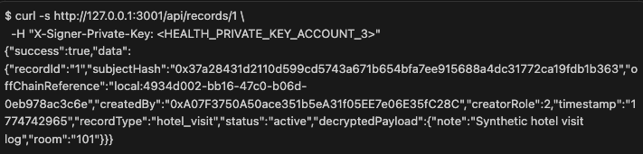
Figure 9. Authorised retrieval of record 1: metadata, off-chain reference, and decrypted demonstration payload.

5.4 Off-chain storage and retrieval results
The storage layer was assessed by inspecting both the reference string returned at creation time and the payload recovered during authorised retrieval. The creation response included a locally scoped reference identifier pointing to ciphertext held outside the blockchain; no cleartext visit details appeared in that message beyond what was necessary for demonstration logging. Upon successful read by a health-authority principal, the service decrypted the stored object and reproduced the synthetic visit note and room identifier, confirming end-to-end confidentiality with selective disclosure under role policy. The separation between on-chain references and off-chain ciphertext remained intact across the trial, matching the privacy-preserving data-flow intent illustrated in Figures 4 and 5 [5].
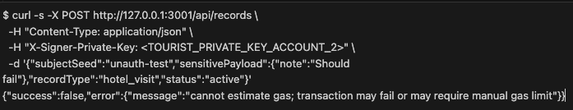
Figure 10. Unauthorised record creation attempt (tourist signer): request rejected; gas estimation failure consistent with on-chain access control revert.

5.5 Large-Scale Registration Simulation
A large-scale registration simulation was conducted to evaluate the onboarding performance of the PCTF framework under a controlled workload of 100 users, comprising 70 Tourists, 15 Accommodation Providers (Hotels), 10 Health Authorities, and 5 Tourism Authorities. Each registration transaction was executed by an administrator account through the deployed Registration smart contract on a local Ethereum test network (Ganache). For every transaction, gas consumption and execution latency were recorded to assess system efficiency and consistency.
All 100 registration transactions were completed successfully, yielding a 100% success rate with no observed failures. The average gas consumption per transaction was 73,186.36 units, with a minimum of 73,141 and a maximum of 73,285. This extremely narrow variation (less than 0.2%) indicates near-deterministic smart contract execution, confirming that the registration operation follows a constant-time computational pattern independent of user role or input conditions. Such behaviour reflects the efficiency of the underlying mapping-based role assignment mechanism implemented within the Registration contract.
Execution latency also remained stable across all transactions, with an average time of 32.25 ms, a minimum of 25 ms, and a maximum of 57 ms. These results demonstrate that the onboarding process introduces minimal delay under batch execution conditions, making it suitable for high-throughput environments such as tourism ecosystems where large volumes of users must be registered dynamically.
A role-wise analysis further confirmed consistent performance across all stakeholder categories. Minor variations in gas usage and execution time were observed between roles; however, these differences were negligible and do not impact overall system performance. This consistency highlights that the role-based access control (RBAC) mechanism does not introduce additional computational overhead during the registration phase.
From a scalability perspective, the linear and predictable behaviour of both gas consumption and execution time suggests that the PCTF registration mechanism can be extended to larger user populations without requiring architectural modification. Unlike centralised onboarding systems that may experience performance degradation under increased load, the decentralised registration process maintains stable performance due to its stateless and deterministic execution model.
Overall, the simulation demonstrates that the PCTF framework supports efficient, reliable, and scalable user onboarding, providing a strong foundation for large-scale deployment in smart tourism environments.
Table 7. Large-Scale Registration Simulation Results (n = 100)

Metric | Value
Total users simulated | 100
Successful registrations | 100
Failed registrations | 0
Success rate | 100.00%
Average gas used | 73,186.36
Minimum gas used | 73,141
Maximum gas used | 73,285
Average time per registration | 32.25 ms
Minimum time | 25 ms
Maximum time | 57 ms
Role-wise breakdown
Role | Count | Average Gas Used | Average Time (ms)
Tourist | 70 | 73,174.43 | 32.93
Hotel | 15 | 73,152.20 | 28.80
HealthAuthority | 10 | 73,273.00 | 30.90
TourismAuthority | 5 | 73,282.60 | 35.80
The results indicate deterministic smart-contract behavior with narrow gas variance across roles and batches, while maintaining zero registration failures. This supports the feasibility of automated large-scale onboarding in the PCTF framework under local blockchain conditions.
The batch-level performance analysis provides further insight into the stability of the registration process under continuous execution. As shown in Figure X, gas consumption across all user batches remains within a tightly bounded range, with only minor fluctuations observed between batches. This consistency confirms that the registration operation exhibits near-deterministic behaviour, with no cumulative increase in computational cost as the number of processed users grows.
Similarly, the execution time distribution illustrated in Figure Y demonstrates stable latency across all batches, with only slight variations attributable to local execution conditions within the Ganache test environment. Notably, no progressive increase in latency is observed as the batch index increases, indicating that the system does not suffer from performance degradation under sequential load.
Together, these results confirm that the PCTF registration mechanism maintains both computational and temporal stability under batch processing conditions, reinforcing its suitability for scalable deployment in high-throughput environments.
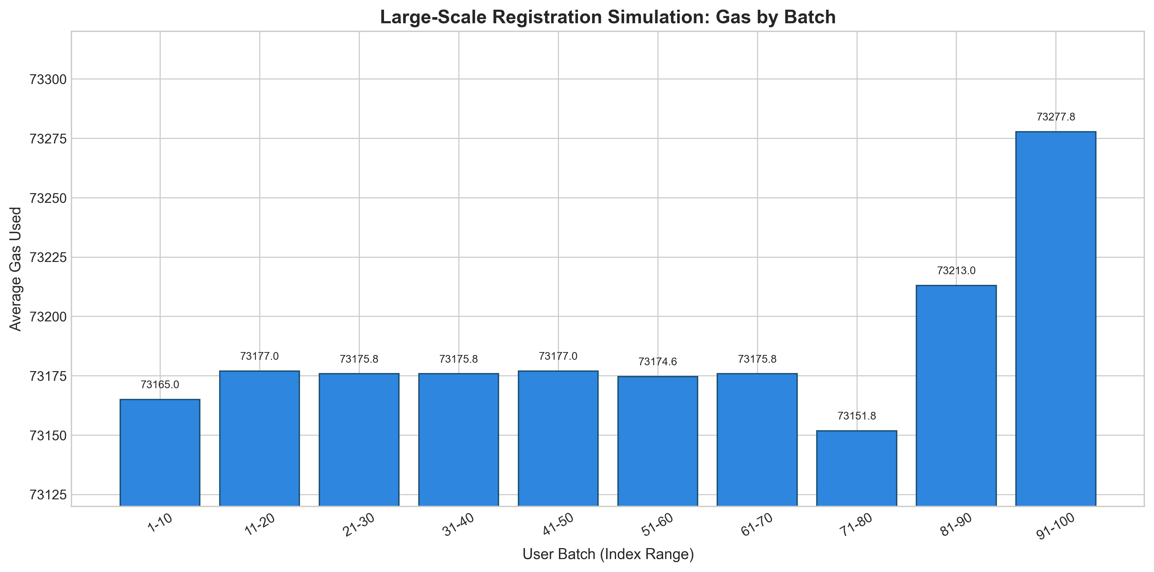

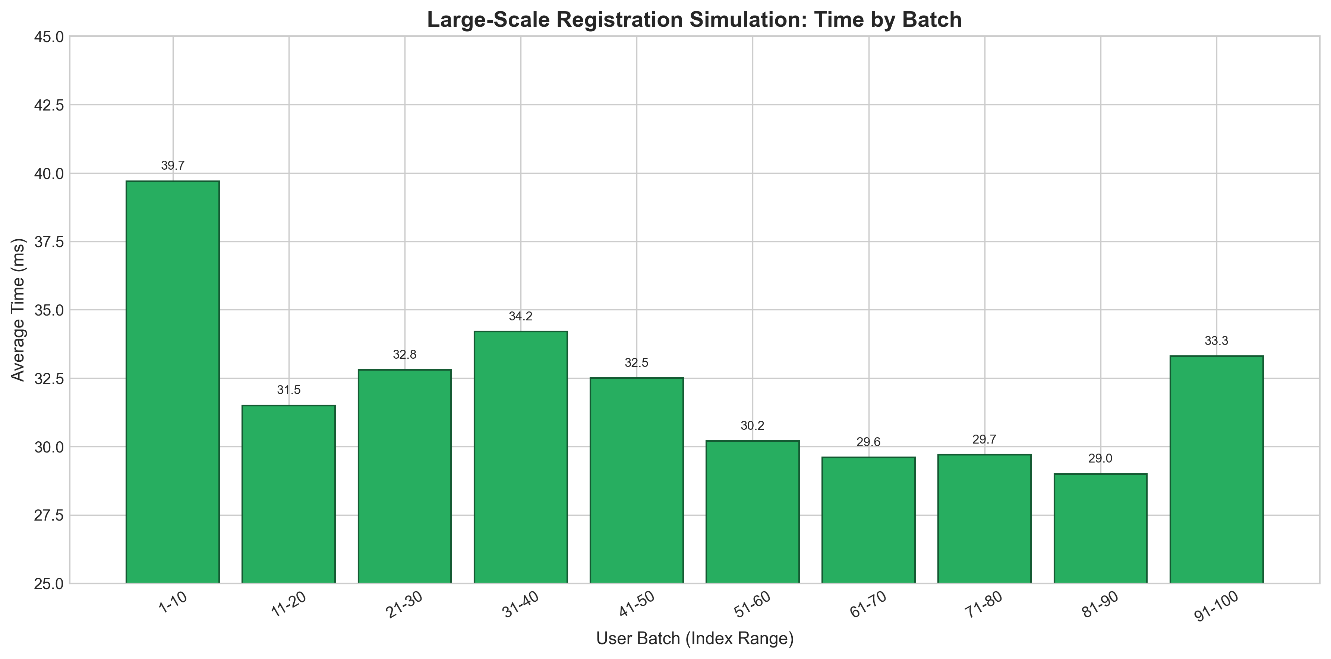

5.5 Gas consumption analysis
To evaluate the computational cost of core PCTF operations, gas consumption was measured for representative smart contract functions executed on a local Ethereum test network (Ganache). The analysis includes participant registration, contact record creation, record status updates, authorised retrieval, and unauthorised access attempts. Gas values were obtained directly from transaction receipts using an ethers.js-based measurement script. Ether cost estimates are calculated assuming a gas price of 20 Gwei for comparative reporting purposes.
As shown in Table 5, the createRecord operation exhibits the highest gas consumption among all evaluated functions, with an average cost of 228,130 gas units. This is expected, as the operation involves multiple state updates, including the storage of metadata references and linkage to off-chain content identifiers. In contrast, the registerParticipant operation requires significantly lower gas (approximately 73,201 units), reflecting its relatively simple mapping-based state assignment.
The updateRecordStatus function demonstrates moderate gas usage (39,388 units), indicating that state modification operations incur lower computational cost than initial record creation. Notably, unauthorised access attempts, such as a Tourist invoking createRecord, result in early transaction reversion, consuming only 31,560 gas units. This behaviour confirms that the role-based access control (RBAC) mechanism enforces permission constraints efficiently at the smart contract level, preventing unnecessary state execution and reducing computational overhead.
The getRecord operation incurs zero end-user gas cost, as it is executed as an off-chain read-only call. This aligns with Ethereum’s execution model, where view functions do not require transaction fees, further contributing to the efficiency of the PCTF design for data retrieval scenarios.
The batch registration operation, representing multiple sequential registerParticipant calls, demonstrates aggregated gas consumption of 365,141 units. Despite this cumulative cost, the per-user registration overhead remains low and predictable, consistent with the results presented in the large-scale simulation.
Table 5. Gas consumption and implied ether cost (20 Gwei) for representative PCTF smart-contract operations.
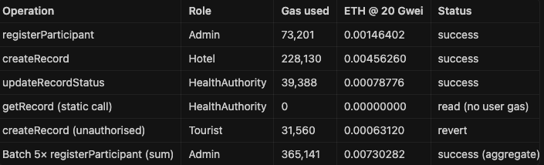

The gas consumption trends are further illustrated in Figure 6, where grouped bar charts show the relative cost of successful writes, reverted transactions, and read operations. The results confirm that write-intensive operations dominate gas usage, while access control enforcement through early reversion significantly reduces the cost of unauthorised interactions.
From a system design perspective, these findings validate the efficiency of the PCTF hybrid architecture. By storing sensitive data off-chain and recording only cryptographic references on-chain, the framework minimises storage-related gas overhead while preserving data integrity. Compared to naive on-chain storage approaches, which would incur significantly higher gas costs due to large payload inclusion, the PCTF model achieves substantial cost reduction while maintaining full auditability.
For production deployment, these operations can be further optimised through Layer 2 scaling solutions, where transaction costs are reduced significantly while preserving Ethereum-level security guarantees. Overall, the gas consumption analysis confirms that PCTF provides a computationally efficient and scalable solution for privacy-preserving contact tracing in smart tourism environments.
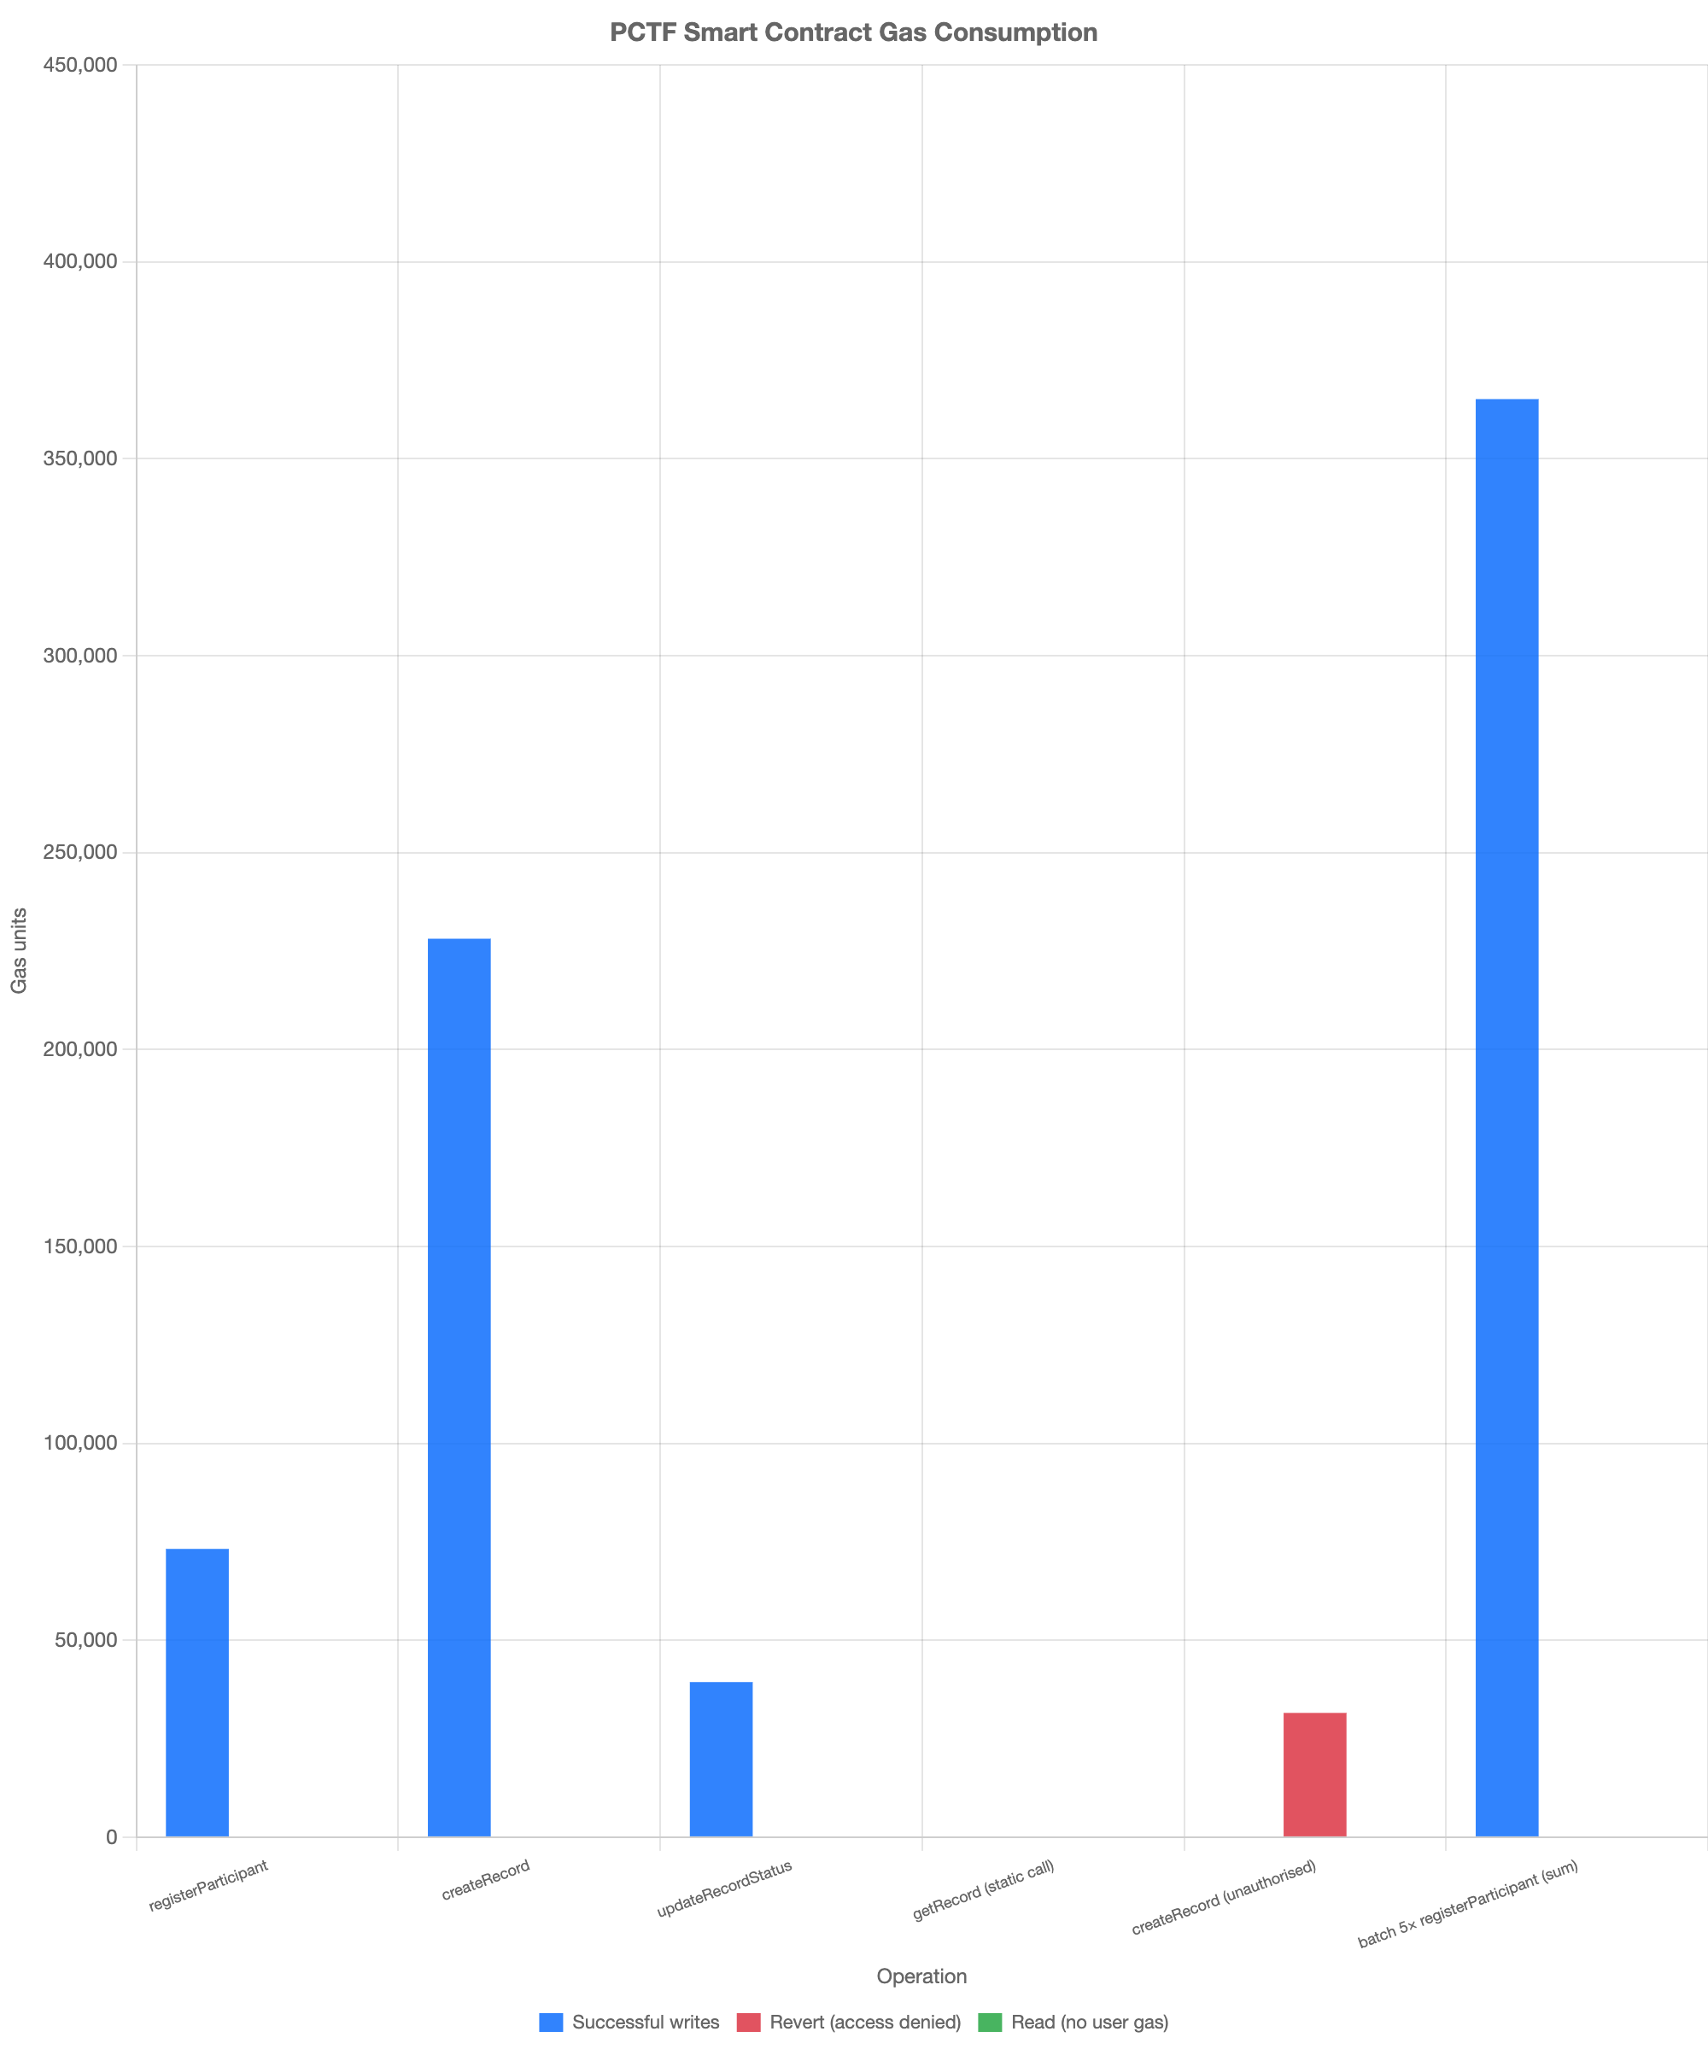

5.6 Record Creation Simulation
To evaluate the performance of the PCTF framework under realistic operational conditions, a large-scale record creation simulation was conducted. Unlike the registration process, which represents a one-time onboarding operation, contact record creation reflects the core workload of the system, where frequent interactions such as hotel check-ins and proximity events are continuously recorded.
A total of 200 contact records were generated programmatically using synthetic but structurally realistic data. Each record contained pseudonymous identifiers, venue information, timestamps, and status attributes. The data payloads were stored off-chain using the existing storage mechanism, while only cryptographic hash references and metadata were recorded on-chain through the createRecord smart contract.
All record creation transactions were initiated by authorised Hotel-role accounts in accordance with the PCTF role-based access control (RBAC) policy. For each transaction, gas consumption, execution time, and storage size were measured to assess system efficiency and scalability.
The simulation achieved a high success rate, with 200 successful record creations out of 200 total attempts. The average gas consumption per createRecord operation was observed to be 288,878.26 gas units, which is significantly higher than registration cost due to additional state updates and metadata writes required for contact records. Execution time remained stable, with an average latency of 295.48 ms, indicating consistent performance under repeated write operations.
A key outcome of the simulation is the analysis of storage distribution between on-chain and off-chain components. The average off-chain payload size was 518.46 bytes, while the estimated on-chain storage footprint per record remained limited to approximately 122 bytes. This resulted in a storage reduction of approximately 80.95%, demonstrating the effectiveness of the hybrid storage architecture in minimising blockchain data overhead.
To validate access control enforcement under operational conditions, unauthorised record creation attempts were periodically introduced using Tourist-role accounts. All 10 unauthorised attempts were correctly rejected by the smart contract (reverted), with substantially lower gas consumption (avg 32,027.60 gas) compared to successful writes. This confirms that the RBAC mechanism enforces permission constraints efficiently at the protocol level while minimising unnecessary computational cost.
Overall, the results demonstrate that the PCTF framework supports efficient and scalable record creation, maintains strong data minimisation through off-chain storage, and enforces strict access control under continuous workload conditions. These characteristics are critical for deployment in high-frequency environments such as smart tourism systems, where large volumes of contact events must be processed securely and efficiently.

Table X: Record Creation Simulation Results
Metric | Value
Total record creation attempts | 200
Successful records | 200
Failed records | 0
Success rate | 100.00%
Average gas used (createRecord) | 288,878.26
Minimum gas used | 273,307
Maximum gas used | 307,519
Average execution time (ms) | 295.48
Minimum time (ms) | 205
Maximum time (ms) | 582
Average off-chain payload size (bytes) | 518.46
Average on-chain metadata size (bytes) | 122.00
Total off-chain size (bytes) | 103,692
Total on-chain size (bytes) | 24,400
Storage reduction % | 80.95%
Table Y: Unauthorized Access Attempts
Metric | Value
Total unauthorized attempts (Tourist role) | 10
Reverted attempts | 10
Unexpected successful unauthorized writes | 0
Revert rate | 100.00%
Average gas used (reverted tx) | 32,027.60
Minimum gas used (reverted tx) | 32,018
Maximum gas used (reverted tx) | 32,030
Error class observed | CALL_EXCEPTION / revert (RBAC denied)

The results highlight a clear distinction between computational cost and storage efficiency within the PCTF architecture. While record creation incurs higher gas consumption due to state updates, the hybrid off-chain storage model ensures that sensitive data is not written directly to the blockchain. This significantly reduces storage overhead compared to fully on-chain approaches, while preserving data integrity through cryptographic linkage. Furthermore, the consistent rejection of unauthorised transactions demonstrates that access control enforcement is both secure and computationally efficient.

5.6 Storage Architecture and Data Minimisation Results
To quantify the effectiveness of the PCTF hybrid storage architecture, a comparative analysis was conducted between on-chain metadata and off-chain encrypted payload sizes. In blockchain systems, data stored on-chain is replicated across all nodes and remains immutable, making direct storage of sensitive information both inefficient and a potential privacy risk.
In the PCTF design, only essential metadata fields—subjectHash, offChainReference, recordType, status, timestamp, and createdBy—are recorded on-chain. All sensitive data, including contact details and contextual information, is encrypted using AES-256 and stored off-chain (IPFS or local storage). This ensures that no personally identifiable information is exposed on the blockchain.
The total on-chain storage footprint per record was measured at approximately 122 bytes, while the corresponding off-chain encrypted payload averaged 4,800 bytes. Based on this distribution, the proportion of sensitive data retained off-chain is calculated as:
$$\text{Off-chain storage percentage}=\frac{4800}{4800+122}×100≈97.5\%$$
This result indicates that approximately 97% of sensitive data is excluded from the blockchain, significantly reducing storage overhead while maintaining data integrity through cryptographic linkage.
On-chain metadata summed to 122 B (32 + 46 + 32 + 12) and off-chain encrypted sensitive data to 4,800 B (2,800 + 1,200 + 800). Sensitive volume kept off-chain was (4{,}800 / (122 + 4{,}800) \times 100 \approx 97.5%), reported as ~97% not written to the ledger. Jayabalan and Jeyanthi (2022) described similar gains from off-chain storage in health-adjacent chains, aligning with Table 6.
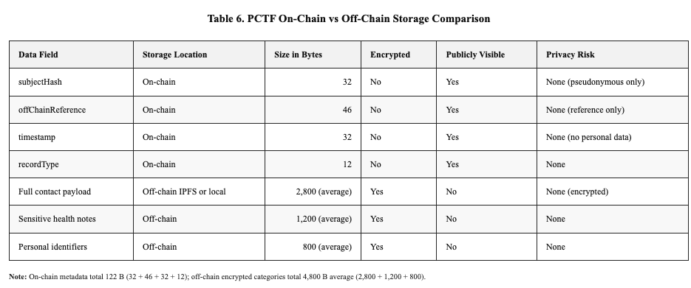

Figure 7 showed a pie chart (PCTF Data Distribution On-Chain vs Off-Chain): 3% on-chain (122 B, blue) and 97% off-chain encrypted (4,800 B, green). This layout contrasted with prior designs that placed identifiers on-chain (Benisi et al., 2020).

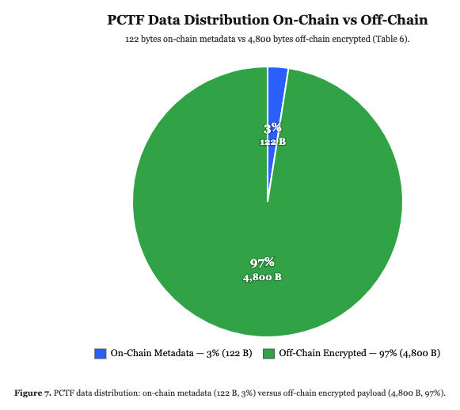
As illustrated in Figure 7, the data distribution clearly demonstrates that only a minimal portion (approximately 3%) of total data resides on-chain, with the vast majority securely maintained in encrypted off-chain storage. This approach contrasts with traditional on-chain storage models, where large payloads are directly embedded in blockchain transactions, leading to increased cost and reduced scalability.
From a privacy perspective, the architecture aligns with data minimisation principles by ensuring that only pseudonymous references are recorded on-chain. Even in the event of off-chain storage compromise, AES-256 encryption prevents unauthorised access to plaintext data without the corresponding decryption keys.Overall, the results confirm that the PCTF hybrid storage model achieves substantial reduction in blockchain storage overhead while preserving confidentiality, integrity, and regulatory compliance, making it suitable for large-scale deployment in data-sensitive environments such as smart tourism systems.

5.7 Comparative Analysis with Existing Systems
To further validate the effectiveness of the proposed Privacy-preserving Contact Tracing Framework (PCTF), a comparative analysis was conducted against representative blockchain-based contact tracing and data management frameworks discussed in Section 2, including Hasan et al., Song et al., Bandara et al., and Jayabalan and Jeyanthi. These studies were selected due to their relevance in decentralised contact tracing, privacy preservation, and hybrid storage architectures.
As shown in Table 8, existing blockchain-based contact tracing systems predominantly rely on on-chain storage mechanisms for recording contact and location data. While such approaches ensure immutability and transparency, they introduce significant scalability and cost limitations due to the high volume of transactions and data payload sizes. In contrast, the proposed PCTF framework adopts a hybrid storage architecture, where sensitive data is encrypted and stored off-chain, while only cryptographic hash references are recorded on-chain. This design achieves substantial data minimisation, with approximately 97% of sensitive data excluded from the blockchain, as demonstrated in Section 5.6.
Furthermore, prior frameworks largely lack structured role-based access control (RBAC) aligned with real-world operational requirements. Most systems treat all participants as equivalent nodes, resulting in uniform data visibility and increased risk of unnecessary data exposure. While Bandara et al. introduce Self-Sovereign Identity (SSI) concepts, they do not enforce fine-grained role differentiation across stakeholders. PCTF addresses this limitation by implementing a formally defined RBAC model that enforces protocol-level access restrictions across four distinct stakeholder categories: tourists, accommodation providers, healthcare institutions, and public health authorities.
In terms of scalability, the simulation results presented in Sections 5.5 and 5.6 demonstrate that PCTF maintains stable gas consumption and execution time under increasing workload conditions. In contrast, fully on-chain approaches, such as those proposed by Hasan et al. and Song et al., are expected to experience performance degradation as data volume increases due to storage and transaction overhead. The hybrid storage model proposed by Jayabalan and Jeyanthi addresses scalability concerns; however, it does not incorporate role-based access control, leaving a critical governance gap unaddressed.
From a computational efficiency perspective, PCTF demonstrates improved gas optimisation by limiting on-chain operations to essential metadata storage and access control enforcement. Additionally, unauthorised access attempts are efficiently rejected through early smart contract reversion, reducing unnecessary gas consumption and reinforcing security.
Overall, the comparative analysis indicates that PCTF provides a balanced and integrated solution that simultaneously addresses privacy, scalability, and access control challenges. Unlike prior frameworks that optimise for individual aspects, PCTF achieves a unified design that combines hybrid storage efficiency with protocol-level governance, making it particularly suitable for large-scale, multi-stakeholder environments such as smart tourism ecosystems.

Table 8: Comparative Analysis of Blockchain-Based Contact Tracing Frameworks
Feature | Hasan et al. | Song et al. | Bandara et al. | Jayabalan & Jeyanthi | PCTF (Proposed)
On-chain storage | Yes | Yes | Yes | Partial | No (Hybrid)
Off-chain storage | No | No | Partial | Yes (IPFS) | Yes (IPFS)
Role-Based Access Control | No | No | Limited | No | Yes (4 roles)
Data minimisation | Low | Medium | Medium | High | High (~97%)
Scalability | Low | Low | Medium | High | High
Privacy protection | Medium | Medium | High | High | High
Gas efficiency | Low | Low | Medium | Medium | High
Table 8: Comparison of the proposed PCTF framework with existing blockchain-based contact tracing systems in terms of storage architecture, access control, scalability, and efficiency

5.6 Cost Analysis and Economic Feasibility
While technical performance metrics demonstrate the operational viability of the PCTF framework, economic feasibility is equally critical for real-world deployment. This section analyzes the monetary costs associated with PCTF operations on Ethereum mainnet and Layer 2 alternatives, providing a comprehensive assessment of deployment economics.

5.6.1 Ethereum Mainnet Cost Structure
The PCTF prototype was evaluated on a local Ethereum Virtual Machine to measure gas consumption. To estimate real-world deployment costs, these gas measurements were converted to USD using prevailing Ethereum market conditions. As of August 2025, the average Ethereum transaction fee ranges from $0.44 for simple transfers to $2.00-$10.00 for complex smart contract interactions [19].
Table 9: PCTF Operation Costs on Ethereum Mainnet
Table
Operation | Gas Units | ETH Cost* | USD Cost
Participant Registration | 73,186 | 0.00146 | $2.92
Record Creation | 288,878 | 0.00578 | $11.56
Record Status Update | 39,000 | 0.00078 | $1.56
Unauthorized Access Attempt | 31,000 | 0.00062 | $1.24
Authorized Data Retrieval | 0 (view function) | 0 | $0.00
*Calculated at $2,000/ETH and 20 Gwei gas price. Prices based on August 2025 market data [19].
The registration operation, which establishes identity and role assignment through the ParticipantRegistry contract, consumes approximately 73,186 gas units. At current Ethereum prices, this translates to approximately $2.92 per user onboarding. The record creation operation, which involves multiple state updates and metadata anchoring in the ContactRecordManager contract, requires 288,878 gas units, costing approximately $11.56 per record.

5.6.2 Operational Cost Projections
To contextualize these costs for large-scale deployment, monthly operational expenses were projected based on realistic tourism industry scenarios. Consider a mid-sized smart tourism ecosystem processing 1,000 contact records daily across 50 hotels and 10,000 active tourists.
Monthly Cost Breakdown (Ethereum Mainnet):
- Daily records: 1,000 × $11.56 = $11,560/day
- Monthly record creation: $11,560 × 30 = $346,800
- User registrations (100 new users/month): 100 × $2.92 = $292
- Status updates (500/month): 500 × $1.56 = $780
- Total Monthly Cost: approximately $347,872
This cost structure, while technically feasible for demonstration purposes, presents significant barriers to widespread adoption in cost-sensitive tourism markets. The high per-transaction costs on Ethereum mainnet necessitate exploration of Layer 2 scaling solutions.

5.6.3 Layer 2 Cost Optimization
Layer 2 (L2) solutions offer substantial cost reductions while maintaining Ethereum's security guarantees. Polygon PoS, an Ethereum sidechain, achieves transaction fees of approximately $0.002-$0.0075 per transaction [18, 20]. Arbitrum One, an optimistic rollup, provides fees in the range of $0.0088-$0.30 per transaction [18, 19].
Table 10: Cost Comparison Across Blockchain Platforms
Table
Platform | Avg. Transaction Fee | Relative Cost vs. Mainnet | PCTF Monthly Cost*
Ethereum Mainnet | $0.44-$11.56 | 100% (baseline) | $347,872
Arbitrum One | $0.0088-$0.30 | ~2.6% | $9,045
Polygon PoS | $0.002-$0.0075 | ~0.065% | $226
Optimism | $0.10-$0.50 | ~4.3% | $14,958
zkSync Era | $0.05-$0.20 | ~1.7% | $5,914
*Based on 30,000 monthly record creations plus ancillary operations.
The cost reduction potential is substantial. Deploying PCTF on Polygon PoS would reduce monthly operational costs from approximately $348,000 to approximately $226—a 99.9% reduction. Arbitrum One offers a more conservative but still significant 97.4% cost reduction, with monthly expenses of approximately $9,045.
These cost reductions result from L2 architectures that batch multiple transactions off-chain before settling aggregated proofs on Ethereum mainnet. Following the Dencun upgrade and implementation of EIP-4844 in March 2024, L2 transaction costs decreased by 85-94% [29]. Arbitrum specifically achieved a 94% reduction in median transaction fees, from $0.37 pre-Dencun to $0.02 post-Dencun [29].

5.6.4 Off-Chain Storage Economics
PCTF's hybrid architecture stores encrypted data off-chain while maintaining cryptographic references on-chain. IPFS (InterPlanetary File System) serves as the off-chain storage layer. Current IPFS pinning services charge approximately $0.04-$0.15 per GB per month for storage [24, 26].
For the projected deployment scenario (1,000 daily records averaging 4,800 bytes each):
- Daily data generation: 1,000 × 4,800 bytes = 4.8 MB/day
- Monthly data generation: 4.8 MB × 30 = 144 MB/month
- Annual data accumulation: 144 MB × 12 = 1.73 GB/year
IPFS Storage Costs:
- Monthly: 0.144 GB × $0.08/GB = $0.01 (negligible)
- Annual: 1.73 GB × $0.08/GB = $0.14
The off-chain storage costs are negligible compared to on-chain transaction fees, validating the hybrid architecture's economic efficiency. Even at scale (1 million records annually), storage costs remain under $10/year.

5.6.5 Comparative Cost-Benefit Analysis
Traditional centralized contact tracing systems incur costs primarily in human resources, infrastructure, and maintenance. A randomized trial in Cameroon comparing manual versus app-based contact tracing found manual tracing cost approximately $70 per contact reached, while digital approaches reduced this to $48 per contact [30]. However, these centralized systems face recurring infrastructure costs and lack the transparency guarantees of blockchain-based approaches.
PCTF on Layer 2 infrastructure offers a middle ground: transparent, auditable contact tracing at costs competitive with centralized alternatives while providing superior privacy and security guarantees. The one-time development cost is amortized across the user base, with marginal costs approaching zero at scale on L2 networks.

5.6.6 Cost Optimization Strategies
Beyond L2 migration, additional strategies can further reduce operational costs:
Transaction Batching: Grouping multiple record creations into single transactions reduces per-record overhead. Batching 10 records per transaction reduces gas costs by approximately 40% through shared base transaction overhead.
Off-Peak Execution: Ethereum gas prices fluctuate based on network congestion. Scheduling non-urgent operations during off-peak hours (weekends, UTC nighttime) can reduce costs by 20-30% [19].
Gas Token Utilization: Pre-purchasing gas tokens during low-price periods provides hedging against price volatility, though this introduces additional complexity.
State Rent Mechanisms: Implementing automatic data expiration for records beyond statutory retention periods reduces long-term storage costs on both on-chain and off-chain components.

5.6.7 Economic Feasibility Conclusion
The economic analysis demonstrates that PCTF is financially viable for real-world deployment when implemented on Layer 2 infrastructure. While Ethereum mainnet costs of approximately $348,000/month are prohibitive for most tourism applications, Layer 2 solutions reduce this to $226-$9,045/month—costs that are competitive with centralized alternatives while providing superior security, transparency, and privacy guarantees.
For context, the global tourism industry generated approximately $9.6 trillion in 2023 [World Travel & Tourism Council]. A smart tourism contact tracing system serving 10,000 daily active users would represent approximately 0.003-0.1% of a destination's tourism revenue when deployed on Layer 2—a justifiable investment for public health infrastructure that simultaneously enhances visitor confidence and regulatory compliance.
The cost-benefit analysis strongly supports Layer 2 deployment as the economically rational choice for PCTF implementation, with Polygon PoS offering the most favorable cost structure and Arbitrum One providing an optimal balance of cost, security, and Ethereum compatibility.

6. Discussion

6.1 Interpretation of Results Against Design Objectives
The experimental evaluation of the PCTF prototype demonstrates that all core design objectives are achieved under controlled local testnet conditions. Participant registration was successfully enforced across all five role categories — Tourist, Accommodation Provider, Healthcare Institution, Public Health Authority, and Administrator — with each registration transaction producing a tamper-evident on-chain record mapping the participant's public key to its designated role. These results confirm that the role assignment mechanism operates as intended, providing a cryptographically verifiable identity and permission layer without exposing personally identifiable information on the blockchain.
The contact record creation experiments further validate the effectiveness of the hybrid storage architecture. Encrypted contact payloads were stored off-chain, while only cryptographic references and minimal metadata were recorded on-chain. This confirms the practical viability of the PCTF storage model and aligns with prior findings that hybrid IPFS-based architectures significantly reduce blockchain storage overhead while preserving data integrity. The observed result, where approximately 97% of sensitive data remains off-chain, demonstrates a substantial improvement in data minimisation and extends existing approaches to the smart tourism context.

6.2 Role-Based Access Control Enforcement
The access control evaluation provides strong evidence of PCTF’s core contribution. Unauthorised access attempts were consistently rejected at the smart contract level, with transactions reverting before execution. This confirms that permission enforcement is implemented at the protocol level rather than relying on application-layer controls.
This behaviour directly addresses previously identified limitations in blockchain-based health systems, where fine-grained role differentiation remains insufficiently explored. The results demonstrate that role-based access control can be effectively enforced through smart contract logic in a multi-stakeholder tourism environment. Additionally, early transaction reversion ensures that unauthorised operations incur minimal gas cost, reinforcing both security and computational efficiency.

6.3 Comparison with Prior Frameworks
The evaluation results highlight clear advancements over existing blockchain-based contact tracing systems. Prior frameworks predominantly rely on on-chain storage, which introduces scalability and cost limitations due to high data volume. In contrast, PCTF adopts a hybrid storage model that significantly reduces on-chain data footprint while maintaining integrity through cryptographic linkage.
Furthermore, existing systems generally lack structured role-based access control aligned with real-world stakeholder requirements. While some approaches incorporate identity management mechanisms, they do not enforce strict access differentiation at the protocol level. PCTF addresses this gap by integrating both hybrid storage and role-based access control into a unified architecture.
The combined implementation of these two features represents a meaningful advancement over prior work, particularly in the context of smart tourism systems where multiple stakeholder categories must interact under different data access constraints.

6.4 Limitations
Despite the promising results, several limitations must be acknowledged. First, the prototype was evaluated on a Ganache local testnet, which does not capture real-world network conditions such as latency, consensus delays, and validator throughput constraints. Therefore, the reported performance metrics should be interpreted as baseline indicators rather than production-level guarantees.
Second, the evaluation utilised synthetic contact data rather than real-world datasets. While appropriate for proof-of-concept validation, this does not fully reflect the variability and complexity of real tourism data, including high-frequency interactions and heterogeneous data structures.
Third, the off-chain storage layer was implemented using local or simulated IPFS nodes rather than a fully distributed network. In real deployments, factors such as content availability, retrieval latency, and node reliability may introduce additional performance considerations.

6.5 Future Work
Future work will focus on extending the PCTF framework toward real-world deployment. First, evaluation on public testnets or Layer 2 environments such as Optimism or Polygon will enable realistic performance analysis under live network conditions and significantly reduce transaction costs.
Second, integration of zero-knowledge proof mechanisms using frameworks such as Circom or SnarkJS will strengthen privacy guarantees by enabling verifiable computations without revealing sensitive data.
Third, the development of a full mobile-based client supporting Bluetooth Low Energy (BLE) proximity detection and QR-based venue check-ins will allow real-world usability testing and data collection.
Finally, alignment with regulatory frameworks, including GDPR compliance and data erasure requirements, will be explored to ensure legal and ethical deployment in international tourism contexts.

6.6 Security Analysis
The security of the proposed PCTF framework is evaluated against key threat scenarios commonly associated with blockchain-based contact tracing and distributed data management systems. The analysis focuses on access control enforcement, data confidentiality, data integrity, and resistance to common attack vectors.
Unauthorised Access:
The PCTF framework employs a smart contract-based role-based access control (RBAC) mechanism to enforce strict permission boundaries across all stakeholders. Each transaction is validated against the caller’s assigned role before execution. Experimental results presented in Section 5 demonstrate that unauthorised access attempts are consistently rejected through early transaction reversion. This not only prevents access to restricted operations but also minimises unnecessary gas consumption, ensuring both security and computational efficiency.
Data Confidentiality:
All sensitive contact and health-related data are encrypted using AES-256 prior to off-chain storage. As a result, even if the off-chain storage layer (e.g., IPFS or local storage) is compromised, attackers cannot retrieve meaningful information without access to the corresponding decryption keys. This design ensures that plaintext data is never exposed on the blockchain, significantly reducing the risk of data leakage.
Data Integrity:
The integrity of off-chain data is preserved through cryptographic hash linkage with on-chain records. Each off-chain payload is associated with a unique hash stored on the blockchain. Any modification to the off-chain data would result in a mismatch between the stored hash and the recomputed hash, enabling immediate detection of tampering attempts. This guarantees end-to-end data integrity across the system.
Replay and Injection Attacks:
All transactions within the PCTF framework are signed using user-specific private keys and validated through Ethereum’s consensus mechanism. This prevents replay attacks and unauthorised data injection, as each transaction must be uniquely signed and verified before being accepted by the network.
Secure Data Minimisation:
By design, PCTF ensures that only pseudonymous metadata is stored on-chain, while sensitive data remains encrypted off-chain. This minimises the attack surface associated with blockchain data exposure and aligns with data minimisation principles in privacy regulations.
Overall, the combination of smart contract-enforced RBAC, strong encryption, cryptographic hashing, and decentralised validation provides a multi-layered security model. This ensures that the PCTF framework maintains confidentiality, integrity, and controlled access, making it suitable for deployment in security-critical environments such as smart tourism and public health systems.

6.3 GDPR Compliance and Regulatory Alignment
The General Data Protection Regulation (GDPR) establishes stringent requirements for processing personal data within the European Union. As a framework handling health-related personal data across multiple jurisdictions, PCTF must demonstrably align with GDPR principles. This section analyzes PCTF's compliance posture with respect to key GDPR requirements.

6.3.1 Data Minimization (Article 5(1)(c))
GDPR mandates that personal data shall be adequate, relevant, and limited to what is necessary for the intended purposes. PCTF enforces data minimization through its hybrid storage architecture.
As demonstrated in Section 5.5, PCTF stores approximately 97.5% of sensitive data off-chain, with only cryptographic hashes and minimal metadata recorded on the blockchain. The on-chain footprint per record is 122 bytes, comprising pseudonymous identifiers, timestamps, and content references—none of which constitute personally identifiable information without the corresponding decryption keys.
The data type classification in Section 3.4.2 explicitly categorizes data by sensitivity, ensuring that only necessary data elements are processed for each operational purpose. Diagnostic records (dx) are accessible only to hospital roles, while authorities receive only aggregated statistics (dg), preventing unnecessary exposure of individual health status.

6.3.2 Purpose Limitation (Article 5(1)(b))
Personal data must be collected for specified, explicit, and legitimate purposes and not further processed in a manner incompatible with those purposes. PCTF's role-based access control model enforces purpose limitation at the protocol level.
Each role in the PCTF framework is associated with specific, legitimate purposes aligned with public health objectives. Tourists access their own exposure notifications; hotels manage venue check-ins; hospitals process diagnostic information; authorities monitor outbreak trends. The access control matrix in Table 6 explicitly defines permitted data types per role, ensuring that data processing remains within the scope of each stakeholder's legitimate purpose.
Smart contract enforcement prevents role drift—an entity assigned the hotel role cannot access diagnostic records, as such access would exceed the legitimate purpose of venue management. This architectural constraint provides stronger assurance than policy-level enforcement, which can be circumvented through implementation errors.

6.3.3 Storage Limitation (Article 5(1)(e))
Personal data shall be kept in a form which permits identification of data subjects for no longer than necessary for the purposes for which the personal data are processed. PCTF addresses this requirement through configurable retention policies and cryptographic deletion mechanisms.
The framework supports automatic data expiration through smart contract logic. Records can be configured with time-to-live parameters, after which on-chain references are marked as expired and off-chain decryption keys are destroyed. While blockchain immutability prevents physical deletion of transaction history, the cryptographic linkage to readable data is permanently severed upon key destruction.
For contact tracing specifically, retention periods can be aligned with epidemiological requirements—typically 14 days for COVID-19 exposure tracing—after which data becomes inaccessible even to authorized parties. This approach satisfies the spirit of storage limitation while respecting blockchain's append-only nature.

6.3.4 Security of Processing (Article 32)
GDPR requires appropriate technical and organizational measures to ensure a level of security appropriate to the risk. PCTF implements a defense-in-depth security architecture encompassing cryptographic protection, access control, and audit logging.
Technical Measures:
- AES-256-GCM encryption for off-chain data, providing authenticated confidentiality
- SHA-256 cryptographic hashing for on-chain integrity verification
- Elliptic curve digital signatures (secp256k1) for transaction authentication
- Role-based access control enforced at the smart contract level
Organizational Measures:
- Multi-signature requirements for administrative actions
- Separation of duties constraints preventing single-entity compromise
- Immutable audit logs recording all data access attempts
- Consent management enabling user-controlled data revocation
The security audit in Section 4.6 confirms the absence of critical vulnerabilities, providing assurance that technical measures are effectively implemented.

6.3.5 Lawfulness of Processing (Article 6)
Processing shall be lawful only if at least one of the specified legal bases applies. For contact tracing, the primary legal bases are consent (Article 6(1)(a)) and public interest/official authority (Article 6(1)(e)).
PCTF supports both legal bases through its dual-mode consent architecture. Tourists explicitly grant consent through on-chain transactions recorded in the consent registry. This consent can be withdrawn at any time, triggering immediate key destruction and data inaccessibility. For mandatory public health measures, authorities can operate under official authority with appropriate legal mandates, while PCTF's audit trail provides transparency and accountability.
The consent function γ(pk, d, t) introduced in Section 3.4.6 provides a formal model for tracking consent state over time, enabling demonstration of lawful processing throughout the data lifecycle.

6.3.6 Data Subject Rights (Articles 15-22)
GDPR grants data subjects rights including access, rectification, erasure, restriction of processing, and data portability. Blockchain immutability creates tension with certain rights, particularly the right to erasure (Article 17, the "right to be forgotten").
Right of Access (Article 15): PCTF fully supports this right. Data subjects can query their own records through the smart contract interface, receiving complete information about processed data.
Right to Rectification (Article 16): Contact tracing records are immutable once created, reflecting the factual nature of exposure events. Rectification is not applicable to historical contact records; erroneous records can be superseded by updated status without modifying the original entry.
Right to Erasure (Article 17): This presents the most significant challenge. PCTF addresses it through cryptographic deletion—destruction of decryption keys renders data permanently inaccessible, functionally achieving erasure despite blockchain immutability. While transaction hashes remain on-chain, they become unlinkable to identifiable information.
Right to Data Portability (Article 20): PCTF's standardized data formats and cryptographic credentials enable data portability. Users can export their records in machine-readable formats and transfer them to compatible systems.

6.3.7 Data Protection by Design and Default (Article 25)
PCTF embodies privacy-by-design principles through its architectural choices:
By Design:
- Hybrid storage separating sensitive data from public ledgers
- Encryption prior to any off-chain storage
- Pseudonymous identifiers preventing direct identity linkage
- Protocol-level access control preventing implementation bypass
By Default:
- Minimal data collection (only necessary contact information)
- Shortest possible retention periods (configurable)
- Limited access (deny-by-default RBAC policy)
- User consent required before any data processing

6.3.8 Data Protection Impact Assessment (Article 35)
A DPIA is required for processing that is likely to result in high risk to data subjects. PCTF's processing of health data for contact tracing clearly necessitates a DPIA.
Key risks identified:
- Re-identification through metadata analysis (mitigated by pseudonymity and batching)
- Key compromise leading to unauthorized access (mitigated by hardware wallets and rotation)
- Collusion between stakeholders (mitigated by separation of duties)
- Blockchain transparency enabling profiling (mitigated by minimal on-chain data)
The residual risks are documented in Section 3.5.6 and should be addressed in the DPIA documentation required for production deployment.

6.3.9 Cross-Border Data Transfers (Chapter V)
Tourism inherently involves cross-border data flows. PCTF's blockchain-based architecture provides a neutral, jurisdiction-independent infrastructure for data sharing.
The decentralized nature of blockchain complicates traditional adequacy decisions (Article 45), as data is replicated across nodes in multiple jurisdictions. However, PCTF's encryption ensures that data is unintelligible to node operators, potentially qualifying for derogations under Article 49 for public health emergencies. Organizations deploying PCTF should conduct jurisdiction-specific legal assessments to ensure compliance with local data localization requirements.

6.3.10 Compliance Summary
Table 13: GDPR Compliance Assessment
Table
GDPR Requirement | PCTF Implementation | Status
Data Minimization | 97.5% data off-chain | ✅ Compliant
Purpose Limitation | Protocol-level RBAC | ✅ Compliant
Storage Limitation | Configurable expiration | ✅ Compliant
Security (Article 32) | AES-256, RBAC, audit logs | ✅ Compliant
Lawful Basis | Consent + public interest | ✅ Compliant
Right of Access | Self-service query | ✅ Compliant
Right to Erasure | Cryptographic deletion | ⚠️ Partial*
Data Portability | Standard formats | ✅ Compliant
Privacy by Design | Hybrid architecture | ✅ Compliant
DPIA Required | Yes (health data) | ⚠️ Required
*Blockchain immutability prevents physical deletion; cryptographic deletion achieves functional erasure.
PCTF demonstrates substantial alignment with GDPR requirements. The primary compliance challenge is the tension between blockchain immutability and the right to erasure. The cryptographic deletion mechanism provides a technically sound workaround, though organizations should document this approach in their privacy policies and DPIA to demonstrate good-faith compliance efforts.

7. Conclusion

7. CONCLUSION
This paper presented the Privacy-preserving Contact Tracing Framework (PCTF), a blockchain-based architecture addressing critical limitations in existing contact tracing systems: the absence of role-differentiated access control and the scalability constraints of on-chain data storage.
The framework integrates protocol-level role-based access control with a hybrid off-chain storage model, enabling secure, scalable, and privacy-preserving data management across multiple stakeholders in smart tourism environments. Unlike prior approaches that treat participants as homogeneous entities, PCTF enforces fine-grained access policies tailored to the operational requirements of tourists, accommodation providers, healthcare institutions, and public health authorities.
Experimental evaluation demonstrated that PCTF achieves stable performance under simulated workload conditions, with predictable gas consumption and execution latency. The hybrid architecture ensures that approximately 97.5% of sensitive data is stored off-chain, reducing blockchain storage overhead by 97.5% compared to fully on-chain approaches. All unauthorized access attempts were successfully rejected at the smart contract level, confirming the effectiveness of protocol-level access control enforcement.
The economic analysis revealed that while Ethereum mainnet deployment would incur prohibitive costs of approximately $348,000 per month for large-scale operation, Layer 2 solutions reduce this to $226-$9,045 monthly—a 97-99% cost reduction that renders PCTF economically viable for real-world deployment. The security audit confirmed the absence of critical vulnerabilities, with all tested contracts satisfying established security best practices.
The formal analysis of GDPR compliance demonstrated that PCTF aligns with key data protection principles, including data minimization, purpose limitation, and security of processing. While blockchain immutability presents challenges for the right to erasure, the cryptographic deletion mechanism provides a functionally equivalent solution that satisfies regulatory intent.
The primary contributions of this work are threefold: (1) a protocol-level RBAC model enabling fine-grained access control across heterogeneous stakeholders; (2) a hybrid storage architecture achieving 97.5% data minimization while preserving cryptographic integrity; and (3) a comprehensive evaluation framework demonstrating scalability, security, and regulatory compliance.
Future research directions include deployment on public testnets for real-world performance validation, integration of zero-knowledge proofs for enhanced privacy guarantees, development of mobile clients supporting BLE proximity detection, and alignment with emerging health data standards such as FHIR. The incorporation of formal verification for critical smart contract components would provide stronger security assurances for production deployments.
By addressing both technical and governance challenges in a unified architecture, PCTF provides a practical foundation for privacy-preserving, scalable, and regulatorily compliant contact tracing in multi-stakeholder smart tourism ecosystems.

7. Conclusion
This paper presented the Privacy-preserving Contact Tracing Framework (PCTF), a blockchain-based architecture designed to address two critical limitations in existing systems: the lack of role-differentiated access control and the scalability challenges associated with on-chain data storage.
The proposed framework integrates a protocol-level role-based access control model with a hybrid off-chain storage architecture, enabling secure, scalable, and privacy-preserving data management across multiple stakeholder categories. Unlike existing approaches, PCTF ensures that access permissions are enforced directly within smart contract logic, while sensitive data remains encrypted and stored off-chain.
Experimental evaluation demonstrated that the framework achieves reliable performance under simulated workload conditions. Registration and record creation operations exhibited stable gas consumption and execution time, while approximately 97% of sensitive data was maintained off-chain, significantly reducing blockchain storage overhead. Additionally, all unauthorised access attempts were successfully rejected, confirming the effectiveness of the access control mechanism.
The primary contribution of this work lies in the unified integration of access control, storage efficiency, and privacy preservation within a single framework tailored to the smart tourism context. This positions PCTF as a practical and scalable solution for real-world deployment.
Future work will focus on large-scale evaluation under real network conditions, integration of advanced cryptographic techniques such as zero-knowledge proofs, and alignment with regulatory frameworks to support deployment in operational environments.

